Type of Pipelining:
- Software Pipelining
1) Can Handle Complex Instructions
2) Allows programs to be reused
- Hardware Pipelining
1) Help designer manage complexity – a complex task can be divided into smaller, more manageable pieces.
2) Hardware pipelining offers higher performance

Pentium processor architecture:
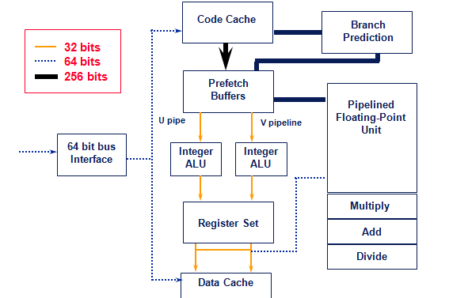
Pentium registers:
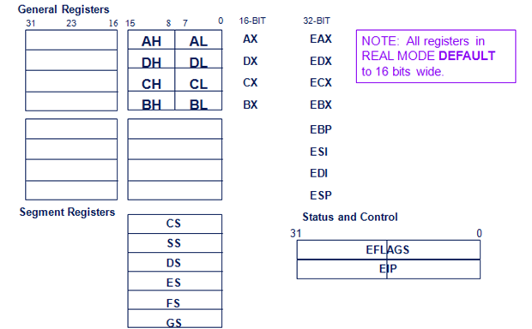
Pipelining on the 486/Pentium
- 486 has a 5-stage pipeline
  - Fetch
    - Instructions can have variable length and can make this stage out of sync with other stages. This stage actually fetches about 5 instructions with a 16 byte load
  - Decode1
    - Decode opcode, addressing modes – can be determined from the first 3 bytes
  - Decode2
    - Expand opcode into control signals and more complex addressing modes
  - Execute
  - Write Back
    - Store value back to memory or to register file

