EX: arithmatic operation
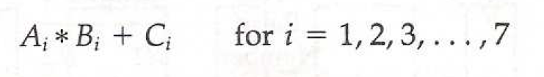

Each sub operation is to be performed in a segment within a pipeline. Each segment has one or two registers and a combinational circuit
The sub operations in each segment of the pipeline are as follows:
