**Overview**

**1.1 Internet**

Interconnected network of computer networks

**ARPAnet**

Advanced Research Project Agency1969 – four computers connected

**NSFnet**

National Science Foundation  
Use of the Internet was originally limited to government, research and academic use.  
1991 Commercial ban lifted

**Intranet &Extranets**

* **Intranet**
  + A private network contained within an organization or business used to share information and resources among workers.
* **Extranet**
  + A private network that securely shares part of an organization’s information or operations with external partners

**Growth of Internet**

**Year**

**1969**

**1989**

**1992**

**1995**

**2001**

**2002**

**2003**

**2006**

**Host Computers**

**4**

**100,000**

**1,000,000**

**8,000,000**

**109,000,000**

**147,000,000**

**171,600,000  
439,000,000**

**The World Wide Web**

MCj03078760000[1]The graphical user interface to information stored on some of the computers connected to the Internet

**Internet Standards & Coordination**

**The Internet Society**: A professional organization that provides leadership in addressing issues related to the future of the Internet

**Web Standards and the W3C Consortium**

* W3C – World Wide Web Consortium
  + Develops recommendations and prototype technologies related to the Web
  + Produces specifications, called Recommendations, in an effort to standardize web technologies

**Network Overview**

**Network** -- two or more computers connected together for the purpose of communicating and sharing resources

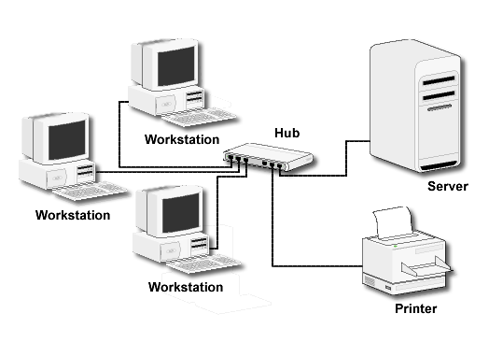

**Networks Types**

**LAN** -- **Local Area Network**: Usually confined to a single building or group of buildings

**MAN -- Metropolitan Area Network**: Connects computer resources in a local geographical area.

**WAN -- Wide Area Network:** Usually uses some form of public or commercial communications network to connect computers is widely dispersed geographical areas.

**A WAN connecting two LANs**

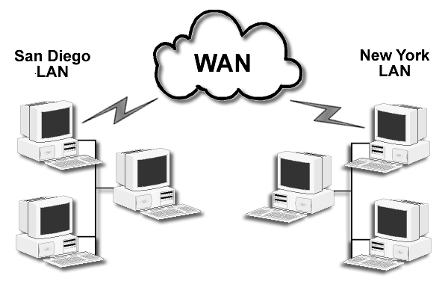

**Internet Infrastructure**

* **Internet Backbone**A high capacity communication link that carries data gathered from smaller links that interconnect with it.
* **NAP – Network Access Point**Access points or junctions to the Internet Backbone in major cities.

**The Client/Server Model**

Client/Server can describe a relationship between two computer programs – the "client" and the "server".

* **Client:** requests some type of service (such as a file or database access) from the server.
* **Server:** responds to the request and transmits the results to the client over a network

**The Client/Server Model**

* The Internet Client/Server Model
  + Client -- Web Browser
  + Server -- Web Server

**Web Client**

* Connected to the Internet when needed
* Usually runs web browser (client) software such as Internet Explorer or Netscape
* Uses HTTP (Hypertext Transfer Protocol)
* Requests web pages from server
* Receives web pages and files from server

**Web Server**

* Continually connected to the Internet
* Runs web server software (such as Apache or Internet Information Server)
* Uses HTTP (Hypertext Transfer Protocol)
* Receives request for the web page
* Responds to request and transmits status code, web page, and associated files

**MIME Type**

* **Multi-Purpose Internet Mail Extension:** a set of rules that allow multimedia documents to be exchanged among many different computer systems

**Internet Protocols**

* **Protocols:** Rules that describe the methods used for clients and servers to communicate with each other over a network.

There is no *single* protocol that makes the Internet and Web work.

A number of protocols with specific functions are needed.

**FTP File Transfer Protocol**

* A set of rules that allow files to be exchanged between computers on the Internet.
* Web developers commonly use FTP to transfer web page files from their computers to web servers.

**FTP** is also used to download programs and files from other servers to individual computers.

**E-mail Protocols**

* Sending E-mail
  + C:\Users\Terry\AppData\Local\Microsoft\Windows\Temporary Internet Files\Content.IE5\P0Q8U2HW\MCj04247880000[1].wmfSMTP Simple Mail Transfer Protocol
* Receiving E-mail
  + POP (POP3) Post Office Protocol
  + IMAP Internet Mail Access Protocol

**HTTP Hypertext Transfer Protocol**

A set of rules for exchanging files such as text, graphic images, sound, video, and other multimedia files on the Web.

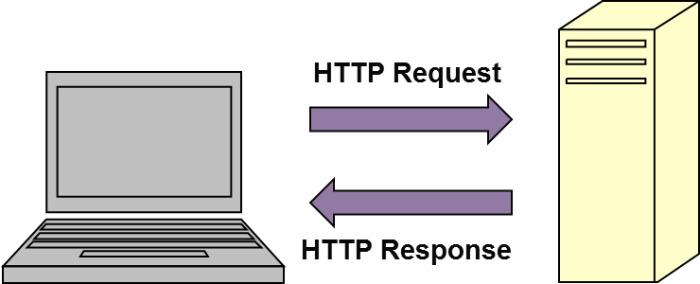

* Web browsers send HTTP requests for web pages and their associated files.
* Web servers send HTTP responses back to the web browsers.

**TCP/IP  
Transmission Control Protocol / Internet Protocol**

* TCP/IP has been adopted as the official communication protocol of the Internet.
* TCP and IP have different functions that work together to ensure reliable communication over the Internet.

**TCP Transmission Control Protocol**

* Purpose is to ensure the integrity of communication
* Breaks files and messages into individual units called packets

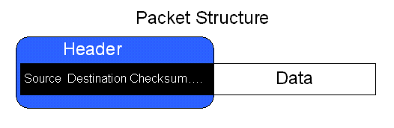

**IP Internet Protocol**

* A set of rules that controls how data is sent between computers on the Internet.
* IP routes a packet to the correct destination address.
* The packet gets successively forwarded to the next closest router (a hardware device designed to move network traffic) until it reaches its destination.

**IP Address**

* Each device connected to the Internet has a unique numeric IP address.
* These addresses consist of a set of four groups of numbers, called octets.   
   **64.233.167.99 will get you Google!**
* An IP address may correspond to a domain name.

**Domain Name**

* Locates an organization or other entity on the Internet
* Domain Name System
  + Divides the Internet into logical groups and understandable names
  + Associates unique computer IP Addresses with the text-based domain names you type into a web browser
  + **Browser: http://google.com**
  + **DNS: 64.233.187.99**

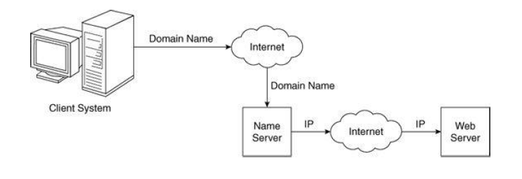

**URL Uniform Resource Locator**

Represents the address of a resource on the Internet.

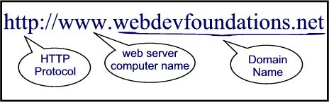

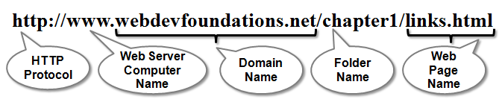

**TLD Top-Level Domain Name**

* A top-level domain (TLD) identifies the right-most part of the domain name.
* Current generic TLDs:  
  .com, .org, .net, .mil, .gov, .edu, .int, .aero, .asia, .cat, .jobs, .name, .biz, .museum, .info, .coop, .pro, .travel

**Counrty Code TLDs**

* Two character codes originally intended to indicate the geographical location (country) of the web site.
* In practice, it is fairly easy to obtain a domain name with a country code TLD that is not local to the registrant.
* Examples: .tv, .ws, .au, .jp, .uk

**Domain Name System**

* The Domain Name System (DNS) associates Domain Names with IP addresses.
* Each time a new URL is typed into a web browser:

1. The DNS is accessed

2. The corresponding IP address is obtained and returned to the web Browser

3. The web browser sends an HTTP request to the destination computer with the corresponding IP address

4. The HTTP request is received by the web server

5. The necessary files are located and sent by HTTP responses to the web browser

6. The web browser renders and displays the web page and associated files

**Markup Languages**

* **SGML** Standard Generalized Markup Language
  + A standard for specifying a markup language or tag set
* **HTML** Hypertext Markup Language
  + The set of markup symbols or codes placed in a file intended for display on a web browser.
* **XM**L – extensible Markup Language
  + A text-based language designed to describe, deliver, and exchange structured information.
  + It is not intended to replace HTML –   
    it is intended to extend the power of HTML by separating data from presentation.
* **XHTML** – extensible Hypertext Markup Language
  + Developed by the W3C as the reformulation of HTML 4.0 as an application of XML.
  + It combines the formatting strengths of HTML 4.0 and the data structure and extensibility strengths of XML.

**Apache**

Apache began as the NCSA server, http, with some added features. Apache is the most widely used Web server.

The primary reasons are as follows:

* Apache is an excellent server because it is both fast and reliable.
* Furthermore, it is open-source software, which means that it is free and is managed by a large team of volunteers, a process that efficiently and effectively maintains the system.
* Finally, it is one of the best available servers for Unix-based systems, which are the most popular for Web servers.

Apache is capable of providing a long list of services beyond the basic process of serving documents to clients. The Apache begins execution; it reads its configuration information from a file and sets its parameters to operate accordingly.