Improving an illumination system in the microscopic imaging of nuclear tracks using a light emitting diode source
Saja F. Hassan1 Prof. Iman Tarik AL-Alawy2 Ass. Prof. Hazim G. Daway3

1Department of Physics, 2Department of physics, 3Depatment of physics,
College of Education , College of science college of science,
AL-Mustansiriyah University, AL-Mustansiriyah University AL-Mustansiriyah University
Baghdad, Iraq Baghdad, Iraq Baghdad, Iraq.

hazimdo@uomustansiriyah.edu.iq
Saja.basam1981@gmail.com
Abstract

In this study, a vision of images of the nuclear tracks was increased by two ways firstly: designing a new lighting system based on the LED, instead of using traditional light using fluorescent light in the optical microscope. Due to the high dynamic range of the LED light, we have a high vision and a higher number of tracks when shooting. secondly: we suggested anew scale depended on counting nuclear tracks ,it is called (No-Reference Image Quality-Assessment Based On Wavelet Transforms ( NIQWT)), It was calculated measured quality of captured images and no reference scales like (The Entropy of the First Derivative (EFD), average gradient (AG),measure of enhancement( EMEE), and NIQWT), It is calculated through correlation coefficient for these scales ,we concluded highest value of nuclear tracks for NIQWT scale than other Non- reference scales ;and in the statically results illustrated photography when using LED device much better than Florescent light in the optical microscopy. Finally: these processes led to augment numbering of nuclear tracks discovered.

Keywords
No reference image quality; nuclear tracks; CR-39 Detector; LED Device; and wavelet transforms based on the histogram.

Introduction
No-reference quantitative assessment of image quality is one of the most pressing and difficult problems of image processing. Generalized contrast is the most important quantitative characteristic which determines the objective quality of the image. Currently, the development of new effective methods of no-reference measuring of generalized contrast for RGB image in nuclear tracks which have the level of lightness, which are acceptable to implement the processing in real time, is one of the most urgent tasks of image pre-processing and analysis of image[1, 2].
The objective of study is the process of no reference measurements for image quality assessment of nuclear tracks.
The purpose of the work is to increase number of nuclear track discovered when various levels of lightness in the optical microscope using a light emitting diode source.
Currently, the development of new on reference image quality scale (NIQWT) for the accurate of nuclear tracks an urgent need in the nuclear studies because augment analysis image led to increase number of nuclear tracks discovered. This will also improve the accuracy of nuclear measurements better than traditional methods of manual counting of nuclear tracks.

- Theoretical part

- CR-39 track detector
Polyallyl diglycol carbonate - PADC which is generally referred as CR-39 the most sensitive of the nuclear track recording plastics. It was first discovered by Cartwright, this detector consists of short polyallyle chains joined by links containing carbonate and die ethylene glycol groups into a dense three dimensional network [3]. The chemical form of CR-39 is [ $C12H18O7]$ .
The general characteristics of CR-39 can be summarized as [4]:
- Amorphous polymer.
- Optically clear.
- Environmentally very stable.
- Having a closed packed and uniforms molecular structure.
- Having non – solvent chemical etchant.
- Highly cross – linked thermoset.
- Sensitive to heavy ion damage.
- Track formation
When a charged nuclear particle enters the plastic it creates a trail of radiation damage along its path, known as a latent track, shown schematically [5]. This may be revealed by etching the plastic in a suitable reagent such as (NaOH).
- Alpha Particle (nuclear track)
The alpha particles were emitted by Americium ${}_{}^{241}{Am}$decay, impinge on a ${}_{ }^{9}{Be_{4}}$ target, producing neutrons over a broad range of energies with an average energy around 4.2 MeV and a maximum around 10 MeV [6,7,8]

- Light
Light is just one portion of the various electromagnetic waves flying
through space. These waves have both a frequency and a length, the values of which are distinguishing light from other forms of energy on the electromagnetic spectrum. Light is emitted from a body due to Incandescence, Electric Discharge, Electro luminescence and Photoluminescence [9]. Images cannot exist without light. To produce an image, the scene must be illuminated with one or more light sources.
with surface and some artificial light source. Moreover we determine general factors that effect on the light equality assessment.
- Light Emitting Diode (LED):
The basic operating principle behind light emitting diodes is inducing Conduction by negatively charged carriers (n-type) and some by positively charged carriers (p-type). When charged carriers of different types recombine the energy released may be emitted as light [10]. LED lamps are the newest addition to the list of energy efficient light sources. While LED lamps emit visible light in a very narrow spectral band, they can produce "white light". This is accomplished with either a red-blue-green array or a phosphor-coated blue LED lamp. LED lamps have made their way into numerous lighting applications including exit signs, traffic signals, under-cabinet lights, and various decorative applications. Though still in their infancy, LED lamp technologies are rapidly Progressing and show promise for the future [11]see Figure(1).

- No reference image quality
No reference image quality refers to the problem of predicting the visual quality of image without any reference to an original optimal quality image. This assessment is the most difficult problem in the field of image objective analysis [12], since many unquantifiable factors play a role in human perceptions of quality, such as aesthetics, cognitive relevance, learning, context etc. [13]. No reference image quality is useful to many still image applications as assessment equality of high resolution image, JPGE image compressed [14] moreover, this objective method can measure image equality depending on verity of lightness and contrast.
- Image quality measurement (IQM):
Measuring the quality of image is a complicated and hard process since humans
opinion is affected by physical and psychological parameters. Many techniques are proposed for measuring the quality of the image but none of it is considered to be perfect for measuring the quality. Image quality assessment plays an important role in the field of image processing [15]. Image quality metrics are divided in to two kinds subjective and objective, human visual system (HVS) is an example of subjective IQM. Most IQM are related to the difference between two images (the original and distorted image) and this type is called reference IQM, other IQM are not related to the difference between the two images like reduce reference IQM and no reference IQM. There are four no-reference scales used:

- The Entropy of the First Derivative (EFD) Image
The entropy of the first derivative is defined as follows [16]:
𝐻 (𝜒) = Σ P(𝑥𝑘) log2 [1/P(x)] (1)

Where 𝜒 is a discrete random variable with possible outcomes x1, x2,... x n;
(𝑥𝑘)is the probability of the outcome 𝑥𝑘 . The outcome is understood as a gray
level in the lightness image, and its probability is calculated by:
P (𝑥𝑘) = 𝑛𝑘/ 𝑁t (2)
Where 𝑘 = 1 , 2 , . . . 𝑛, is the total number of possible lightness in the image, 𝑁t is the total number of pixels, and n k is the number of pixels that have lightness level 𝑥𝑘. The higher entropy value denotes a better contrast in the image.

- Average Gradient
Average gradient shows the fine contrast, texture characteristic, and clarity of an
image. The higher value of average gradient indicates that the image has more intensity levels and is clearer [17], the average gradient, ̅ can be defined as follows:

$∇↑2 G=\frac{1}{\left(M-1\right)\left(N-1\right)\sqrt{∇}}↑2f\left(i,j\right)+ ∇↑2f\left(i,j\right)/2$ (3)
Where ( i) and (j ) are the gradients on the row and column direction, respectively. M and N are the numbers of the row and column of the enhanced image, respectively.

- Measure of Enhancement (EMEE)
Measure of enhancement (EMEE) is a no-reference or blind-image quality metric. EMEE measures the image enhancement or image contrast measure which is principally evaluated by dividing the image into k1 k2 blocks. If an image x(n,m) is split into k1 k2 blocks of size I1 I2, EMEE of the image for a given class {Φ} of orthogonal transforms, is given by Equation (4).

EMEE =1/k1 k2⅀⅀20 log 𝑰max k, l(/𝑰min k, l+ C (4)

where I min k, l and Imax k, l(Φ) and (Φ) are the minimum and maximum intensity levels of the image x(n,m) inside the block after processing the block by Φ transform based enhancement algorithm. C is a small constant which is equal to 0.0001 to avoid dividing by (0). This measure of enhancement is used to find the average ratio of maximum to minimum intensities in decibels. Intuitively it makes sense, since it takes the average ratio of maximum to minimum points in each block over the entire image.
A high value of EME is desired as it demonstrates the better image quality and higher
edge detection capabilities[18].

- Quality assessment using wavelet transforms (NIQWT)
Wavelet transforms is the one of the important and benefit tool of Image processing , it has been used in image processing, data in Compression, and signal processing[18], and the histogram for HL component for the original images and figure 3 show this transform for the blurring images. No-reference quantitative assessment of image quality is one of the most pressing and difficult problems of image processing. Generalized contrast is the most important quantitative characteristic which determines the objective quality of the image. . Objective Development of new histogram-based method for no-reference measurement of generalized contrast of complex images on the basis of the mean value for all contrast values of all pairs of image elements (objects and background) for various definitions of contrast kernel Method. Analysis of known approaches to measurement of a local contrast of the image elements, of known methods of the quantitative assessment of generalized contrast of complex images as well of the results of experimental research for a series of complex real and test images allowed to reveal inherent patterns (accordance to basic requirements to the definition of contrast, the nature and the dynamic of contrast changes at the linear transformations of the brightness scale), which are manifested depending on the use of the different definitions of the contrast kernels and the metrics of generalized contrast of images. Results. New histogram-based method for no-reference measurement of generalized contrast for complex images is proposed. No-reference contrast metrics for the histogram-based measuring of generalized contrast complex images on the basis of the average contrast of image elements for different definitions of contrast kernel is Proposed [19].In the histogram curves we can see the max value is inversely proportional with the Gaussian blue factor, this feature can be invested in the creation of non-reference quality measure where:
$WBH=1/max⁡(hist)$ (5)
Where
WBH: no-reference wavelet quality.
H: histogram of part of (LH) only.
N: values of image.
Note: [HH, LH, HL, and LL] these images divided from original image in Matlab program.
The steps of Mat lab software program follow:
1. Input color image c(x,y,i)
Where i= 1,2,3,
- 2. convert c image to lightness image by using
I=(0.299*c(:,:,1)+0.587*c(:,:,2)+.114*c(:,:,3))

- 3.Calculating NIQWT for I component
4. Estimating LH component only
5. Finding histogram for LH component
6. Calculating WBH by equation:
WBH = 1 /max (hist.)

2. Results and Discussion
Images with good lighting and contrast are of great important in statistics and a clear vision of nuclear tracks ,image quality analysis is important for these tracks.in this study determined image quality changing the lighting and contrast by controlling the level of light taken by images of tracks under optical microscope. We used the new lighting system with the light emitting diode(LED) to generate different levels of lightness from (93)Lux to (1255)Lux as needed. For the nuclear part we has been taken apiece of CR-39 detector with thickness (500)mm$²$ and area (1*1)cm after exposure to the radioactive (3) min from distance (3.5)cm and worked on it chemical etching for (180)min after drying the detector, the video images were taken at different lighting levels by use lux meter see Figure(1) device with (HDEC-50B) camera size (3)µpixel with zoom (40x)under optical microscope see Figure (1).Finally we wanted in this work answer about question .Any value of better light level for the image taken under optical microscope? Answer, it was the proposal of a non-reference scale of images depending on the number of nuclear track see table (1).and then calculated correlation coefficient for all images for many level light as well as different no-reference scales like (EFD, AG, EME, and NIQWT) .At the (949)Lux light level, we found the highest correlation coefficient by used (NIQWT) scale depending on counting of track, which means that the detected nuclear tracks of this area will be increased; see table (2). image thus, there are illuminance levels that make the image having high quality which lays in Figure (4-a) using no reference NIQWT scale of correlation coefficient better than EFD scale in Figure (4-b) and other scale ,see Figures (4-c & d), Figures (5-a , b, c, and d) .

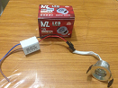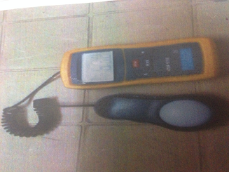

Figure (1) Show LED device and digital lux meter model (LX1330B) china.

Conclusion
In this research we study the distribution of lighting for LED device and capture nine groups of images with different illuminance see Figure (3), which have been used to new Quality scale (NIQWT) to calculation quality factor; as well as other well-known standards (Entropy, average gradient, and EME)and the extraction of correlation coefficient with comparison with manually account for nuclear tracks for different levels lightness (93,112,215,334,410,678,949,1238,and 1255)LUX see Table (1) & Figure (6,7); we concluded it has a better coefficient of correlation to specific intensity level resulting in the resolution tracks(alpha particles) on CR-39 detector, thereby increasing of nuclear tracks discovered ,due to the increase in an illumination (lightness) in which images are captured with, does not mean necessarily increasing in the quality of the image thus, there are lighting levels that make the image having high quality which lays in (949) Lux.

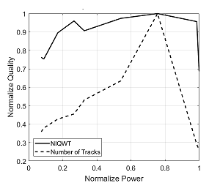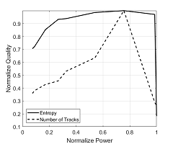

Figure (4-a)correlation coefficient of NIQWT for a image Figure (4-b)correlation coefficient of EFDfor a image

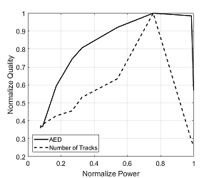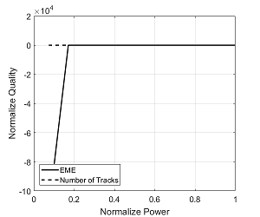

Figure (4-c)correlation coefficient of AED for a image Figure (4-d)correlation coefficient of EMEE for a image

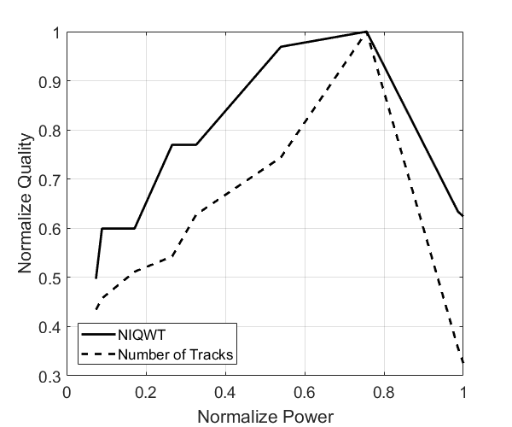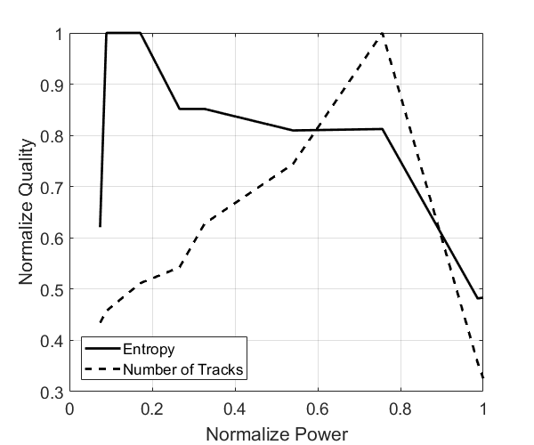

Figure (5-a)correlation coefficient of NIQWT for e image Figure (5-b)correlation coefficient of EFD for e image

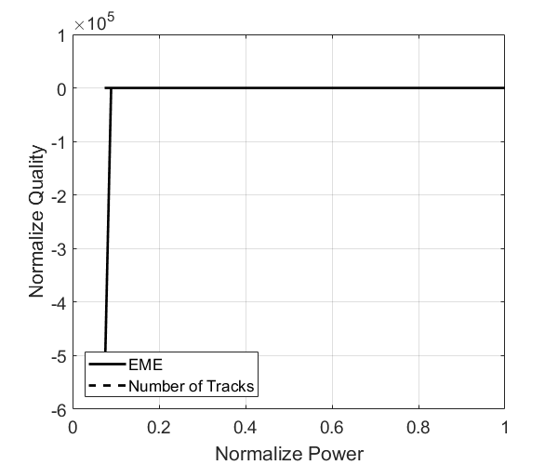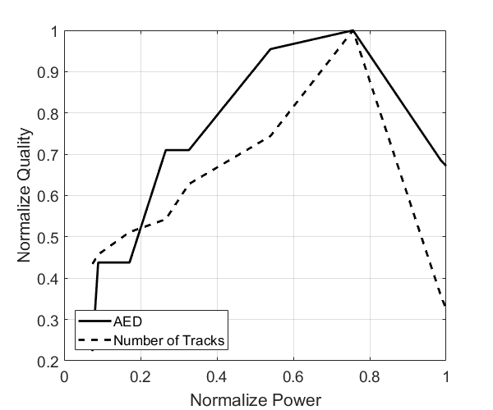

Figure (5-c)correlation coefficient of EMEE for e image Figure (5-d)correlation coefficient of AED for e image

Table (1) Describe manually accounting of nuclear tracks for nine groups of images captured with different levels of lightness under optical microscope.

a-i(9) | a-i(8) | a-i(7) | a-i(6) | a-i(5) | a-i(4) | a-i(3) | a-i(2) | a-i(1) | N0. Of Tracks
1255 | 1238 | 949 | 673 | 410 | 334 | 215 | 112 | 93 | Levels of lightness(LUX)
42 | 46 | 129 | 96 | 81 | 70 | 66 | 59 | 56 | Image a
39 | 43 | 126 | 93 | 78 | 67 | 63 | 56 | 53 | Image b
37 | 41 | 124 | 91 | 76 | 65 | 61 | 54 | 51 | Image c
32 | 36 | 139 | 86 | 71 | 60 | 56 | 49 | 46 | Image d
36 | 40 | 143 | 90 | 75 | 64 | 60 | 53 | 50 | Image f
38 | 42 | 145 | 92 | 77 | 66 | 62 | 55 | 52 | Image e
45 | 49 | 152 | 99 | 84 | 73 | 69 | 62 | 59 | Image g
51 | 55 | 158 | 105 | 90 | 79 | 77 | 68 | 65 | Image h
43 | 38 | 150 | 97 | 83 | 71 | 58 | 60 | 57 | Image i

Table (2) the best color for no reference quality in comparing with intensity of light to correlation coefficients.
1255 | 1238 | 949 | 678 | 410 | 334 | 215 | 112 | 93 | Intensity of light (Lux)
0.6433 | 0.5516 | 0.4367 | 0.0648 | 0.5434 | 0.2033 | 0.3423 | 0.5509 | 0.4204 | Correlation coefficients of EFD
0.8794 | 0.5967 | 0.3510 | 0.4765 | 0.5591 | 0.2025 | 0.2859 | 0.3981 | 0.6807 | Correlation coefficients of AG
0.4885 | 0.4121 | 0.2894 | 0.1046 | 0.2835 | 0.2837 | 0.4108 | 0.1741 | 0.2155 | Correlation coefficients of EMEE
0.7870 | 0.6067 | 0.1089 | 0.2418 | 0.6328 | 0.2736 | 0.0926 | 0.6149 | 0.8789 | Correlation coefficients of NIQWT

Figure (6) The value of illumance (93) Lux for d(1) image
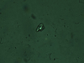
Figure (6) The value of illumance (112 )Lux for d(2) image
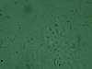
Figure (6) The value of illumance (215) Lux for d(3) image
Figure (6) The value of illumance (334) Lux for d(4) image
Figure (6) The value of illumance (410) Lux for d(5) image
Figure (6) The value of illumance (673) Lux for d(6) image
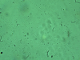
Figure (6) The value of illumance (949) Lux for d(7) image

Figure (6) The value of illumance (1238) Lux for d(8) image
Figure (6) The value of illumance (1255) Lux for d(9) image

___________________________________________________________________

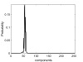
Figure (7) show histogram for d (1) image
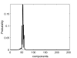
Figure (7) show histogram for d (2) image
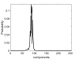
Figure (7) show histogram for d (3) image
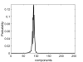
Figure (7) show histogram for d (4) image
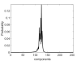
Figure (7) show histogram for d (5) image
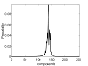
Figure (7) show histogram for d (6) image
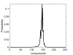
Figure (7) show histogram for d (7) image

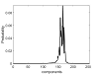
Figure (7) show histogram for d (8) image
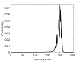
Figure (7) show histogram for d (9) image

Reference (Bibliography)
[1] Wang Z., Bovik A. C., Sheikh H. R., Simoncelli E. P. Image quality assessment: From error visibility to structural similarity, IEEE Transactions on Image Processing, 2004, Vol. 13, No. 4, pp. 600–612. DOI: 10.1109/TIP.2003.819861.
[2] Wang Z., Bovik A. C., Lu L. Why is image quality assessment so difficult?, IEEE International Conference on Acoustics, Speech and Signal Processing, Orlando, FL, USA, May 2002, Vol. 4,
[3] Al – Rubyie, Atheer Qassim Muryoush, "Radioactive detection on the blood samples of cancer patients diseases by using CR-39 detector and its effect on cytogenetic", AL-Nahrain University, Ms.c thesis, p 7, (2004).
[4] Fala Hatem Taha, "Radiation dose assessment for ionizing and ultraviolet radiations using CR-39, lexan and LR-115 nuclear track detectors", AL-Nahrain University, Ms.c thesis, p 23, (2011).
[5] Nikezic, D. and Yub, K.N. "Formation and growth of tracks in nuclear track materials", Materials Science and Engineering 46, p 51–123, (2004).
[6] Peeples, Cody Ryan, "Alternatives to the americium-beryllium neutron sourcefor the compensated neutron porosity log raleigh", North Carolina University, Ms.c thesis, (2007).
[7] Kakavand, T., Haji-Shafeieha, M. AND Ghafourian, H., "STUDY of neutron yield for the 241Am-9Be source", Iranian Journal of Science and Technology, Transaction 33, p. 277 -280, (2009).
[8] Taner Uckan, José March-Leuba, Danny Powell, James D. White and Joseph Glaser, "241AmBe sealed neutron source assessment studies for the fissile mass flow monitor", OAK RIDGE National Laboratory, (2003).

[9] Anil Walia, "Designing with Light- A lighting Handbook " , United Nations Environment Programme ,2006, download from: www.retscreen.net/fichier.php/903/Chapter-Lighting.pdf

[10] Duco Schreuder. "Outdoor Lighting: Physics, Vision, and Perception". Springer-Verlag,2008.

[11] "SLL Lighting Handbook” (published by the Society of Light and Lighting, CIBSE, 2009 download from http: //ezzatbaroudi .files. wordpress. Com /2011 /02/ handbook. pdf.
[12] Z. Wang, and A. C. Bovik, “Why is Image Quality Assessment So Difficult?”, IEEE ICASSP, 02 International Conference on Acoustics, Speech and Signal Processing, Orlando, Florida, USA, pp. 3313-3316, 2002.
[13] Horita, Y., Miyata, T., Gunawan, P. I., Murai, T., and Ghanbari, M., "Evaluation model considering static-temporal quality degradation and human memory for SSCQE video quality," in Proc. SPIE, Lugano, Switzerland, PP. 1601-1611, 2003.
[14] Xin Li, "Blind image quality assessment" in Image Processing Proceedings, International Conference on, vol. 1, pp. I–449, 2002.
[15] Y. A. Y. Al-Najjar, and D. C. Soong, "Comparison of Image Quality Assessment: PSNR, HVS, SSIM, UIQI", International Journal of Scientific & Engineering Research, Volume 3, Issue 8, August-2012 1 ISSN 2229-5518.
[16] T. T. Nguyen, X. D. Pham, D. Kim and J. W. Jeon, “Automatic Exposure
Compensation for Line Detection Applications”, IEEE International Conference on Multisensor Fusion and Integration for Intelligent Systems Seoul, Korea, 2008.

[17]Ahmad SH. Abdul Ghani,"Improvement of underwater image contrast enhancement technique based on histogram modification ", 2015.
[18] R.C. Gonzales, Richard E. Woods," Digital Image Processing" , second edition, Prentice Hall, 2002 .

[19] .Z.Jing, “No reference quality assessment of digital images”, M.Eng., Shandong University, PH.D thesis, 2010.

