0- Basic Syntax
The fundamental syntactic units of HTML are called tags. In general, tags are used to specify categories of content. For each category, a browser has default presentation specifications for the specified content.
The syntax of a tag is the tag’s name surrounded by angle brackets (< and >). Tag names must be written in all lowercase letters. Most tags appear in pairs: an opening tag and a closing tag. The name of a closing tag is the name of its corresponding opening tag with a slash attached to the beginning. For example, if the tag’s name is p, the corresponding closing tag is named /p. Whatever appears between a tag and its closing tag is the content of the tag. A browser display of an XHTML document shows the content of all of the document’s tags; it is the information the document is meant to portray. Not all tags can have content.
The opening tag and its closing tag together specify a container for the content they enclose. The container and its content together are called an element. For example, consider the following element:

<p> This is simple stuff. </p>

The paragraph tag, <p>, marks the beginning of the content; the </p> tag marks the end of the content of the paragraph element.
Attributes, which are used to specify alternative meanings of a tag, can appear between an opening tag’s name and its right angle bracket. They are specified in keyword form, which means that the attribute’s name is followed by an equals sign and the attribute’s value. Attribute names, like tag names, are written in lowercase letters. Attribute values must be delimited by double quotes.
Comments in programs increase the readability of those programs. Comments in XHTML have the same purpose. They can appear in XHTML in the following form:

<! -- Anything except two adjacent dashes -->

Browsers ignore XHTML comments—they are for people only. Comments can be spread over as many lines as are needed. For example, you could have the following comment:
Besides comments, several other kinds of text that are ignored by browsers may appear in an XHTML document. Browsers ignore all unrecognized tags. They also ignore line breaks. Line breaks that show up in the displayed content can be specified, but only with tags designed for that purpose. The same is true for multiple spaces and tabs.
Programmers find XHTML a bit frustrating. In a program, the statements specify exactly what the computer must do. XHTML tags are treated more like suggestions to the browser. If a reserved word is misspelled in a program, the error is usually detected by the language implementation system and the program is not executed. However, a misspelled tag name usually results in the tag being ignored by the
, with no indication to the user that anything has been left out. Browsers are even allowed to ignore tags that they recognize. Furthermore, the user can configure his or her browser to react to specific tags in different ways.

1- Standard XHTML Document Structure
Every XHTML document must begin with an xml declaration element that simply identifies the document as being one based on XML. This element includes an attribute that specifies the version number, which is still 1.0. The xml declaration usually includes a second attribute, encoding, which specifies the encoding used for the document. Following is the xml declaration element, which should be the first line of every XHTML document:

<?xml version = “1.0” encoding = “utf-8”?>

Note that this declaration must begin in the first character position of the document file.
The following command states that the document in which it is included complies
with the XHTML 1.0 Strict standard:
An XHTML document must include the four tags <html>, <head>, <title>, and <body>. The
<html> tag identifies the root element of the document. So, XHTML documents always have an <html> tag immediately following the DOCTYPE command, and they always end with the closing html tag, </html>. The html element includes an attribute, xmlns that specifies the XHTML namespace, as shown in the following element:

<html xmlns = “http://www.w3.org/1999/xhtml”>

Although the xmlns attribute’s value looks like a URL, it does not specify a document. It is just a name that happens to have the form of a URL. An XHTML document consists of two parts, named the head and the body. The <head> element contains the head part of the document, which provides information about the document and does not provide the content of the document. The body of a document provides the content of the document. The content of the title element is displayed by the browser at the top of its display window, usually in the browser window’s title bar.

2- Basic Text Markup
This section describes how the text content of an XHTML document can be formatted with XHTML tags. By formatting, we mean layout and some presentation details. For now, we will ignore the other kinds of content that can appear in an XHTML document.

2.0- Title
The <title> tag is required in all HTML documents and it defines the title of the document.
The <title> element:
- defines a title in the browser toolbar
- provides a title for the page when it is added to favorites
- displays a title for the page in search-engine results
2.1- Paragraphs
Text is normally organized into paragraphs in the body of a document. The XHTML standard does not allow text to be placed directly in a document body. Instead, textual paragraphs appear as the content of a paragraph element, specified with the tag <p>. In displaying the content of a paragraph, the browser puts as many words as will fit on the lines in the browser window. The browser supplies a line break at the end of each line. For example, the following paragraph might be displayed by a browser as shown in Figure 1:
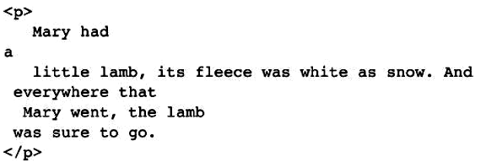
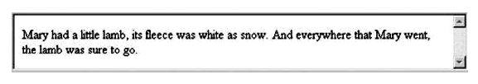
Figure 1 Filling lines
Notice that multiple spaces in the source paragraph element are replaced by single spaces in Figure 1. The following is our first example of a complete XHTML document:
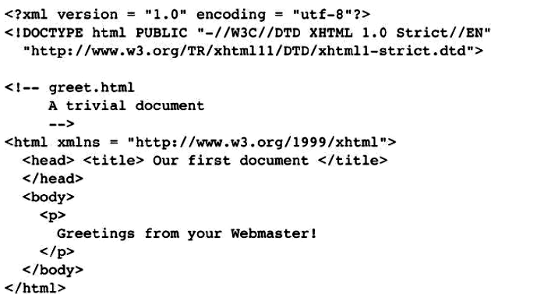
Figure 2 shows a browser display of greet.html.
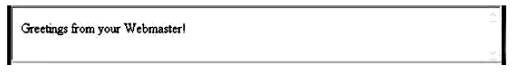
Figure 2 Display of greet.html

If the content of a paragraph tag is displayed at a position other than the beginning of the line, the browser breaks the current line and inserts a blank line. For example, the following line would be displayed as shown in Figure 3:
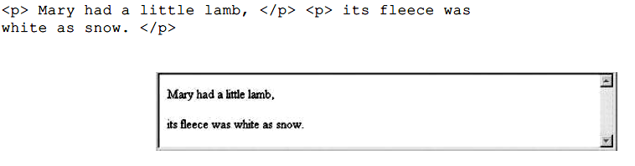
Figure 3 The paragraph element

2.2 Line Breaks
Sometimes text requires a line break without the preceding blank line. This is exactly what the break tag does. The break tag differs syntactically from the paragraph tag in that it can have no content and therefore has no closing tag (because a closing tag would serve no purpose). The break tag is specified as <br />. The slash indicates that the tag is both an opening and closing tag. The space before the slash represents the absent content.
Consider the following markup:
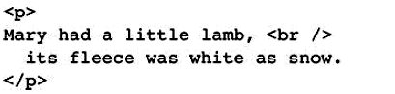
This markup would be displayed as shown in Figure 4.
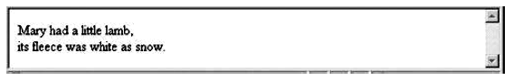
Figure 4 Line breaks

2.3 Preserving White Space
Sometimes it is desirable to preserve the white space in text—that is, to prevent the browser from eliminating multiple spaces and ignoring embedded line breaks. This can be specified with the pre tag—
for example,
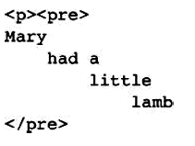
This markup would be displayed as shown in Figure 5. Notice that the content of the pre element is shown in monospace, rather than in the default font.
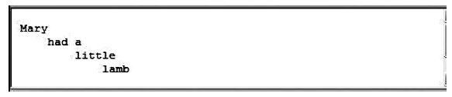
Figure 5 the pre element
A pre element can contain virtually any other tags, except those that cause a paragraph break, such as paragraph elements.

2.4 Headings
Text is often separated into sections in documents by beginning each section with a heading. Larger sections sometimes have headings that appear more prominent than headings for sections nested inside them. In XHTML, there are six levels of headings, specified by the tags <h1>, <h2>, <h3>, <h4>, <h5>, and <h6>, where <h1> specifies the highest-level heading. Headings are usually displayed in boldface font whose default size depends on the number in the heading tag. On most browsers, <h1>, <h2>, and <h3> use font sizes that are larger than that of the default size of text, <h4> uses the default size, and <h5> and <h6> use smaller sizes. The heading tags always break the current line, so their content always appears on a new line. Browsers usually insert some vertical space before and after all headings. The following example illustrates the use of headings:
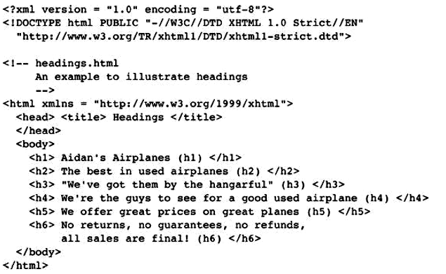
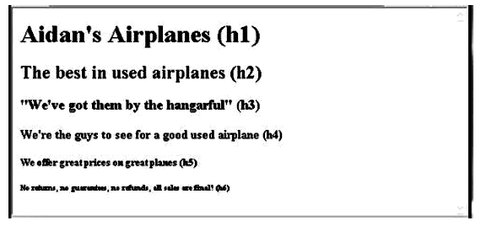
Figure 6 Display of headings.html
2.5 Block Quotations
Sometimes we want a block of text to be set off from the normal flow of text in a document. In many cases, such a block is a long quotation. The <blockquote> tag is designed for this situation. Browser designers determine how the content of <blockquote> can be made to look different from the surrounding text. In many cases, the block of text is indented, either on the left or right side or both. Another possibility is that the block is set in italics. Consider the following example document:
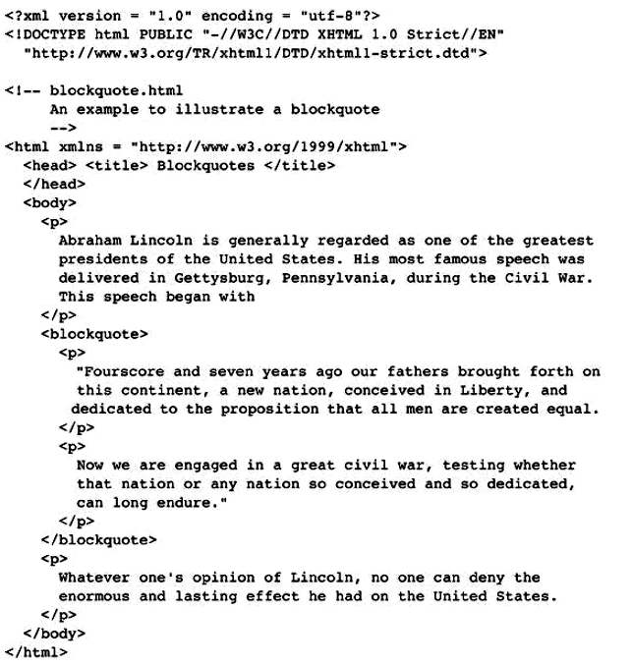
Figure 7 shows a browser display of blockquote.html.

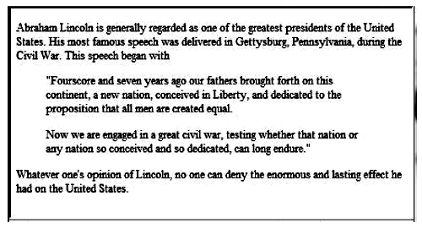
2.6 Font Styles and Sizes
Early Web designers used a collection of tags to set font styles and sizes. For example, <i> specified italics and <b> specified bold. Since the advent of cascading style sheets the use of these tags has become passé. There are a few tags for fonts that are still in widespread use, called content-based style tags. These tags are called content based because they indicate the particular kind of text that appears in their content. Three of the most commonly used content-based tags are the emphasis tag, the strong tag, and the code tag. The emphasis tag, <em>, specifies that its textual content is special and should be displayed in some way that indicates this distinctiveness. Most browsers use italics for such content. The strong tag, <strong> is like the emphasis tag, but more so. Browsers often set the content of strong elements in bold. The code tag, <code>, is used to specify a monospace font, usually for program code. For example, consider the following element:
<code> cost = quantity * price </code> This markup would be displayed as shown in Figure 8.
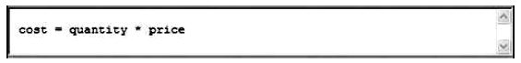
Figure 8 The <code> element
Subscript and superscript characters can be specified by the <sub> and <sup> tags, respectively. These are not content-based tags. For example, X<sub>2</sub><sup>3</sup> + y<sub>1</sub><sup>2</sup> would be displayed as shown in Figure 9.
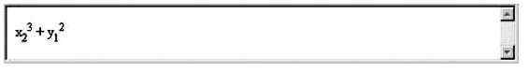
Figure 9 The <sub> and <sup> elements
Character-modifying tags are not affected by <blockquote>, except when there is a conflict. For example, if the text content of <blockquote> is set in italics and a part of that text is made the content of an <em> tag, the <em> tag would have no effect. XHTML tags are categorized as being either block or inline. The content of an inline tag appears on the current line. So, an inline tag does not implicitly include a line break. One exception is br, which is an inline tag, but its entire purpose is to insert a line break in the content.
A block tag breaks the current line so that its content appears on a new line. The heading and blockquote tags are block tags, whereas <em> and <strong> are inline tags. In XHTML, block tags cannot appear in the content of inline tags. Therefore, a block tag can never be nested directly in an inline tag. Also, inline tags and text cannot be directly nested in body or form elements. Only block tags can be so nested. That is why the example greet.html has the text content of its body nested in a paragraph element.

2.7 Character Entities
XHTML provides a collection of special characters that are sometimes needed in a document but cannot be typed as themselves. In some cases, these characters are used in XHTML in some special way—for example, >, <, and &. In other cases, the characters do not appear on keyboards, such as the small raised circle that represents “degrees” in a reference to temperature. Finally, there is the nonbreaking space, which browsers regard as a hard space—they do not squeeze them out, as they do other multiple spaces. These special characters are defined as entities, which are codes for the characters. An entity in a document is replaced by its associated character by the browser. Table 1 lists some of the most commonly used entities.

Table 1 Some commonly used entities
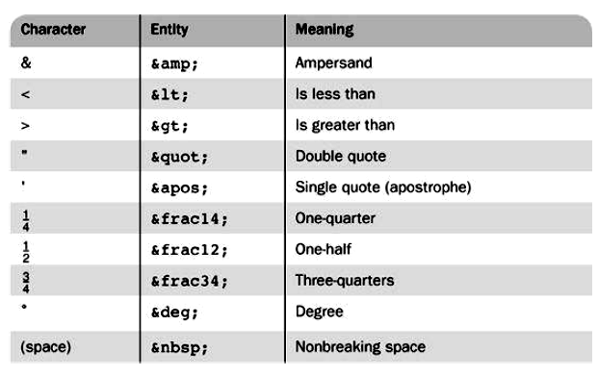

2.8 Horizontal Rules
The parts of a document can be separated from each other, making the document easier to read, by placing horizontal lines between them. Such lines are called horizontal rules, and the block tag that creates them is <hr />. The <hr /> tag causes a line break (ending the current line) and places a line across the screen. The browser chooses the thickness, length, and horizontal placement of the line. Typically, browsers display lines that are three pixels thick. Note again the slash in the <hr /> tag, indicating that this tag has no content and no closing tag.

2.9 The meta Element
The meta element is used to provide additional information about a document. The meta tag has no content; rather, all of the information provided is specified with attributes. The two attributes that are used to provide information are name and content. The user makes up a name as the value of the name attribute and specifies information through the content attribute. One commonly chosen name is keywords; the values of the content attribute associated with the keywords are those which the author of a document believes characterizes his or her document. An example is <meta name = “keywords” content = “binary trees, linked lists, stacks” /> Web search engines use the information provided with the meta element to categorize Web documents in their indices. So, if the author of a document seeks widespread exposure for the document, one or more meta elements are included to ensure that it will be found by Web search engines. For example, if an entire book were published as a Web document, it might have the following meta elements:
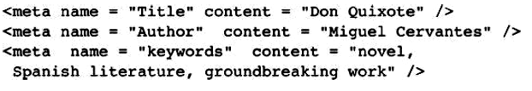

3- Images
The inclusion of images in a document can dramatically enhance its appearance (although images slow the document-download process considerably for clients who do not have high-speed Internet access). The image is stored in a file, which is specified by an XHTML request. The image is inserted into the display of the document by the browser.

3.1 Image Formats
The two most common methods of representing images are the Graphic Interchange Format (GIF, pronounced like the first syllable of jiffy) and the Joint Photographic Experts Group (JPEG, pronounced jay-peg) format. Most contemporary browsers can render images in either of these two formats. Files in both formats are compressed to reduce storage needs and provide faster transfer over the Internet. The GIF format uses 8-bit color representations for pixels, allowing a pixel to have 256 different colors. Files containing GIF images use the .gif (or .GIF) extension on their names. GIF images can be made to appear transparent. The JPEG format uses 24-bit color representations for pixels, which allows JPEG images to include more than 16 million different colors. Files that store JPEG images use the .jpg (or .JPG or .jpeg) extension on their names. The compression algorithm used by JPEG is better at shrinking an image than the one used by GIF. This compression process actually loses some of the color accuracy of the image, but because there is so much to begin with, the loss is rarely discernible by the user. Because of this powerful compression process, even though a JPEG image has much more color information than a GIF image of the same subject, the JPEG image can be smaller than the GIF image. Hence, JPEG images are often preferred to GIF images. The disadvantage of JPEG is that it does not support transparency. A third image format is now gaining popularity: Portable Network Graphics (PNG, pronounced ping. Actually, PNG is a good replacement for both GIF and JPEG because it has the best characteristics of each (the possibility of transparency, as provided by GIF and the same large number of colors as JPEG). One drawback of PNG is that, because its compression algorithm does not sacrifice picture clarity, its images require more space than comparable JPEG images.

3.2 The <img /> Tag
The image tag, <img />, which is an inline tag, specifies an image that is to appear in a document. In its simplest form, the image tag includes two attributes: src, which specifies the file containing the image; and alt, which specifies text to be displayed when it is not possible to display the image. If the file is in the same directory as the XHTML file of the document, the value of src is just the image’s file name. In many cases, image files are stored in a subdirectory of the directory where the XHTML files are stored. For example, the image files might be stored in a subdirectory named images. If the image file’s name is stars.jpg and the image file is stored in the images subdirectory, the value of src would be as follows:
“images/stars.jpg”

<img src = “c210.jpg” alt = “Picture of a Cessna 210” />
The following example extends the airplane ad document to include information about a specific airplane and its image: Some seriously aged browsers are not capable of displaying images. When such a browser finds an <img /> tag, it simply ignores its content, possibly leaving the user confused by the text in the neighborhood of where the image was supposed to be. Also, graphical browsers, which are capable of displaying images, may have image downloading disabled by the browser user. This is done when the Internet connection is slow and the user chooses not to wait for images to download. It is also done by visually impaired users. In any case, it is helpful to have some text displayed in place of the ignored image. For these reasons, the alt attribute is required by XHTML. The value of alt is displayed whenever the browser cannot or has been instructed not to display the image. Two optional attributes of img—width and height—can be included to specify (in pixels) the size of the rectangle for the image. These attributes can be used to scale the size of the image (i.e., to make it larger or smaller). Care must be taken to ensure that the image is not distorted in the resizing. For example, if the image is square, the width and height attribute values must be kept equal when they are changed. The following is an example of an image element:

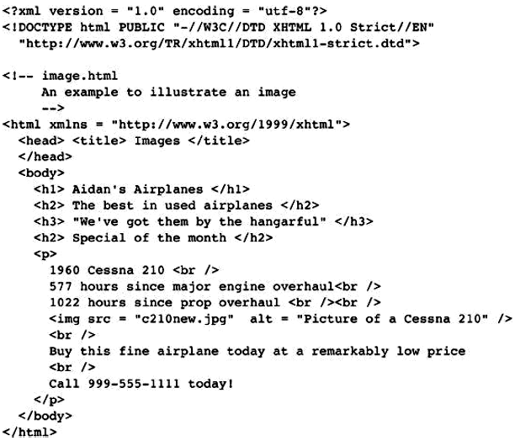

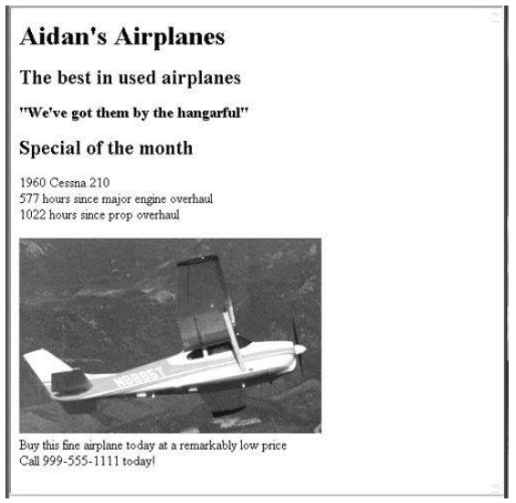
Figure 10 shows a browser display of image.html

4- Hypertext Links
A hypertext link in an XHTML document, which we simply call a link here, acts as a pointer to some particular place in some Web resource. That resource can be an XHTML document anywhere on the Web, or it may be the document currently being displayed. Without links, Web documents would be boring and tedious to read. There would be no convenient way for the browser user to get from one document to a logically related document. Most Web sites consist of many different documents, all logically linked. Therefore, links are essential to building an interesting Web site.

4.1 Links
A link that points to a different resource specifies the address of that resource. Such an address might be a file name, a directory path and a file name, or a complete URL. If a link points to a specific place in any document other than the beginning, that place somehow must be marked. Links are specified in an attribute of an anchor tag (<a>), which is an inline tag. The anchor tag that specifies a link is called the source of that link. The document whose address is specified in a link is called the target of that link.
As is the case with many tags, the anchor tag can include many different attributes. However, for creating links, only one attribute is required: href (an acronym for hypertext reference). The value assigned to href specifies the target of the link. If the target is in another document in the same directory, the target is just the document’s file name. If the target document is in some other directory, the UNIX pathname conventions are used. So, an XHTML file named c210data.html in a subdirectory of the directory in which the source XHTML files—named, say, airplanes—is specified in the href attribute value as “airplanes/c210data.html”. This is the relative method of document addressing. Absolute file addresses could be used in which the entire path name for the file is given. However, relative links are easier to maintain, especially if a hierarchy of XHTML files must be moved. If the document is on some other machine (not the server providing the document that includes the link), obviously the complete URL must be used.c
The content of an anchor tag, which becomes the clickable link the user sees, is restricted to text, line breaks, images, and headings. Links are usually implicitly rendered in a different color than that of the surrounding text. Sometimes they are also underlined. When the mouse cursor is placed over the anchor-tag content and the left mouse button is pressed, the link is taken by the browser. If the target is in a different document, that document is loaded and displayed, replacing the currently displayed document. If the target is in the current document, the document is scrolled by the browser to display the part of the document in which the target of the link is defined. As an example of a link to the top of a different document, consider the following document, which adds a link to the document displayed in Figure 10:
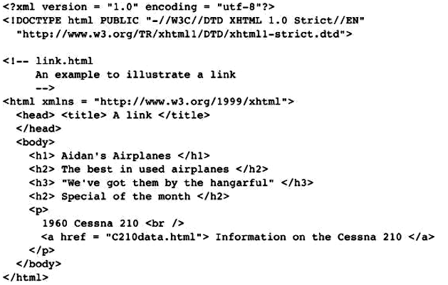
In this case, the target is a complete document that is stored in the same directory as the XHTML document. Figure 11 shows a browser display of link.html. When the link shown in Figure 11 is clicked, the browser displays the screen shown in Figure 12.
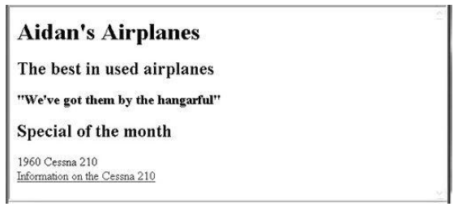
Figure 11 Display of link.html

Figure 12 Following the link from link.html
Links can include images in their content, in which case the browser displays the image together with the link:
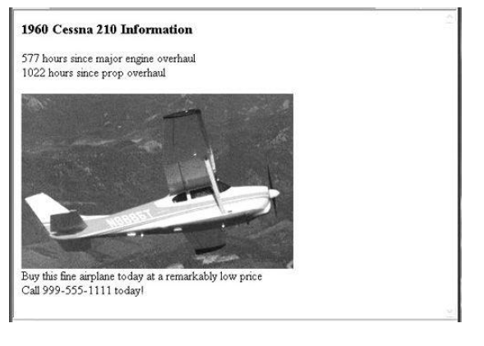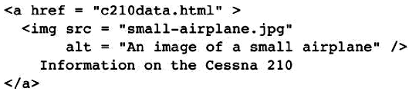
An image itself can be an effective link (the content of the anchor element). For example, an image of a small house can be used for the link to the home page of a site. The content of an anchor element for such a link is just the image element.

4.2- Targets within Documents
If the target of a link is not at the beginning of a document, it must be some element within the document, in which case there must be some means of specifying it. The target element can include an id attribute, which can then be used to identify it in an href attribute. Consider the following example:

<h2 id = “avionics”> Avionics </h2>
Nearly all elements can include an id attribute. The value of an id attribute must be unique within the document. If the target is in the same document as the link, the target is specified in the href attribute value by preceding the id value with a pound sign (#), as in the following example:

<a href = “#avionics”> What about avionics? </a>

When the "What about avionics?" Link is taken; the browser moves the display so that the h2 element whose id is avionics is at the top. When the target is a part or fragment of another document, the name of the part is specified at the end of the URL, separated by a pound sign (#), as in this example:

<a href = “AIDAN1.html#avionics”> Avionics </a>

4.3- Using Links
One common use of links to parts of the same document is to provide a table of contents in which each entry has a link. This technique provides a convenient way for the user to get to the various parts of the document simply and quickly. Such a table of contents is implemented as a stylized list of links by using the list specification capabilities of XHTML. A link should blend into the surrounding text as much as possible so that reading the document without clicking any of the links is easy and natural.

5- Lists
We frequently make and use lists in daily life—for example, to-do lists and grocery lists. Likewise, both printed and displayed information is littered with lists. XHTML provides simple and effective ways to specify lists in documents. The primary list types supported are those with which most people are already familiar: unordered lists such as grocery lists and ordered lists such as the assembly instructions for a new bookshelf. Definition lists can also be defined. The tags used to specify unordered, ordered, and definition lists are described in this section.

5.1- Unordered Lists
The <ul> tag, which is a block tag, creates an unordered list. Each item in a list is specified with an <li> tag (li is an acronym for list item). Any tags can appear in a list item, including nested lists. When displayed, each list item is implicitly preceded by a bullet. The document 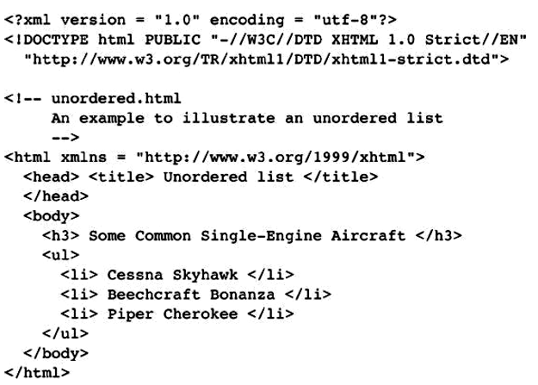
produces a browser display of unordered.html, shown in Figure 13.

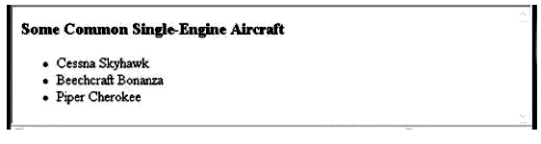
Figure 13 Display of unordered.html

5.2- Ordered Lists
Ordered lists are lists in which the order of items is important. This orderedness of a list is shown in the display of the list by the implicit attachment of a sequential value to the beginning of each item. The default sequential values are Arabic numerals, beginning with 1.
An ordered list is created within the block tag <ol>. The items are specified and displayed just as are those in unordered lists, except that the items in an ordered list are preceded by sequential values instead of bullets. Consider the following example of an ordered list:
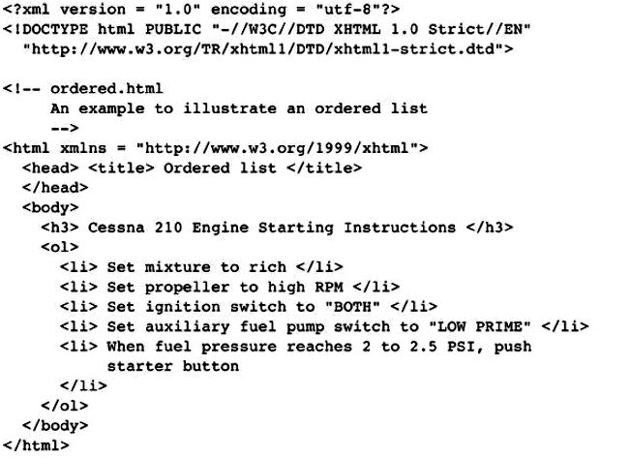
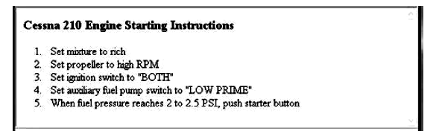
Figure 14 Display of ordered.html

As noted earlier, lists can be nested. However, a list cannot be directly nested; that is, an <ol> tag cannot immediately follow an <ol> tag. Rather, the nested list must be the content of an <li> element. The following example illustrates nested ordered lists:
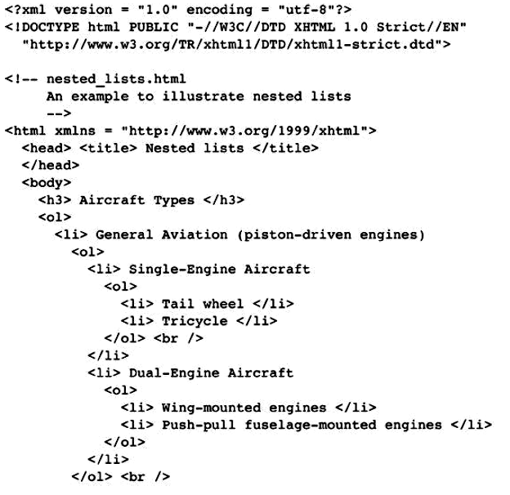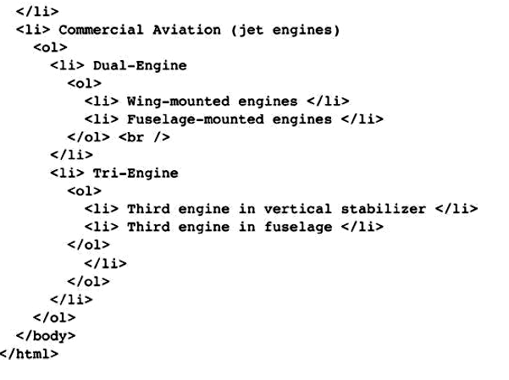

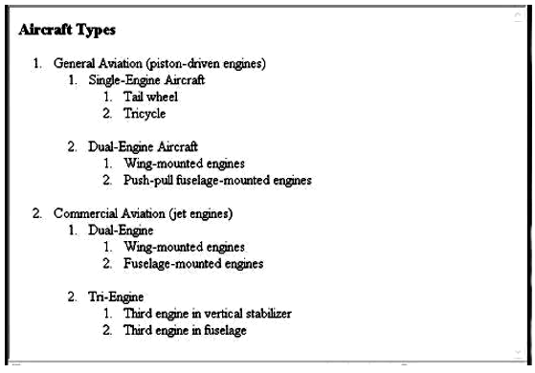

Figure 15 Display of nested_lists.html
One problem with the nested lists shown in Figure15 is that all three levels use the same sequence values. The nested_lists.html example uses nested ordered lists. There are no restrictions on list nesting, provided that the nesting is not direct. For example, ordered lists can be nested in unordered lists and vice versa.

5.3- Definition Lists
As the name implies, definition lists are used to specify lists of terms and their definitions, as in glossaries. A definition list is given as the content of a <dl> tag, which is a block tag. Each term to be defined in the definition list is given as the content of a <dt> tag. The definitions themselves are specified as the content of <dd> tags. The defined terms of a definition list are usually displayed in the left margin; the definitions are usually shown indented on the line or lines following the term, as in the following example:
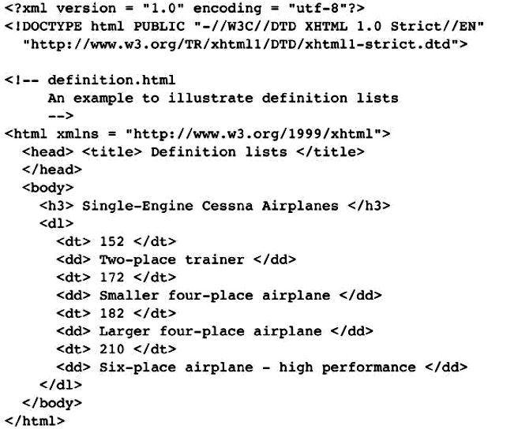
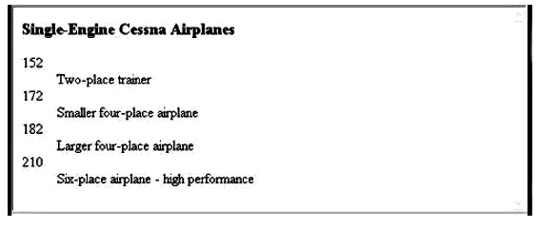
Figure 16 Display of definition.html

6- Tables
Tables are common fixtures in printed documents, books, and, of course, Web documents. Tables provide a highly effective way of presenting many kinds of information. A table is a matrix of cells. The cells in the top row often contain column labels, those in the leftmost column often contain row labels, and most of the rest of the cells contain the data of the table. The content of a cell can be almost any document element, including text, a heading, a horizontal rule, an image, and a nested table.

6.1- Basic Table Tags
A table is specified as the content of the block tag <table>. There are two kinds of lines in tables: the line around the outside of the whole table is called the border; the lines that separate the cells from each other are called rules. A table that does not include the border attribute will be a matrix of cells with neither a border nor rules. The browser has default widths for table borders and rules, which are used if
the border attribute is assigned the value “border.” Otherwise, a number can be given as border’s value, which specifies the border width in pixels. For example, border = “3” specifies a border 3 pixels wide. A border value of “0” specifies no border and no rules. The rules are set at 1 pixel when any nonzero border value is specified. All table borders are beveled to give a three-dimensional appearance, although this is ineffective when narrow border widths are used. The border attribute is the most common attribute for the <table> tag.
In most cases, a displayed table is preceded by a title, given as the content of a <caption> tag, hich can immediately follow the opening <table> tag. The cells of a table are specified one row at a ime. Each row of a table is specified with a row tag, <tr>. Within each row, the row label is specified y the table heading tag, <th>. Although the <th> tag has heading in its name, we call these tags labels to void confusion with headings created with the <hx> tags. Each data cell of a row is specified with a able data tag, <td>. The first row of a table usually has the table’s column labels. For example, if a table as three data columns and their column labels are, respectively, Apple, Orange, and Screwdriver, the irst row can be specified by the following:
<tr>
<th> Apple </th>
<th> Orange </th>
<th> Screwdriver </th>
</tr>
Each data row of a table is specified with a heading tag and one data tag for each data column. For xample, the first data row for our work-in-progress table might be as follows:

<tr>
<th> Breakfast </th>
<td> 0 </td>
<td> 1 </td>
<td> 0 </td>
</tr>
In tables that have both row and column labels, the upper-left corner cell is often empty. This empty ell is specified with a table header tag that includes no content (either <th></th> or just <th />). The following document describes the whole table:
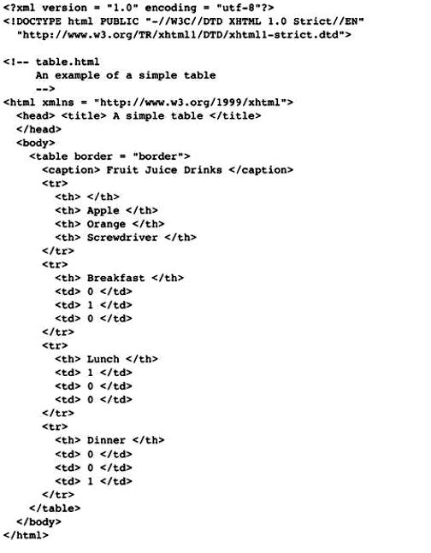
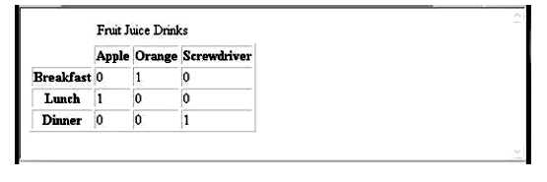
Figure 17 Display of table.html

6.2- The rowspan and colspan Attributes
In many cases, tables have multiple levels of row or column labels in which one label covers two or more secondary labels. For example, consider the display of a partial table shown in Figure 18. In this table, the upper-level label Fruit Juice Drinks spans the three lower-level label cells. Multiple-level labels can be specified with the rowspan and colspan attributes.
Figure 18 Two levels of column labels
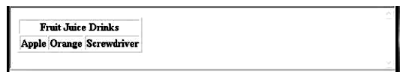
The colspan attribute specification in a table header or table data tag tells the browser to make the cell as wide as the specified number of rows below it in the table. For the previous example, the following markup could be used:
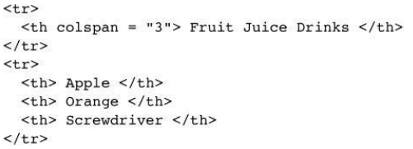
If there are fewer cells in the rows above or below the spanning cell than the colspan attribute specifies, the browser stretches the spanning cell over the number of cells that populate the column in the table. The rowspan attribute of the table heading and table data tags does for rows what colspan does for columns.

A table that has two levels of column labels and also has row labels must have an empty upper-left corner cell that spans both the multiple rows of column labels and the multiple columns. Such a cell is specified by including both rowspan and colspan attributes. Consider the following table specification, which is a minor modification of the previous table:
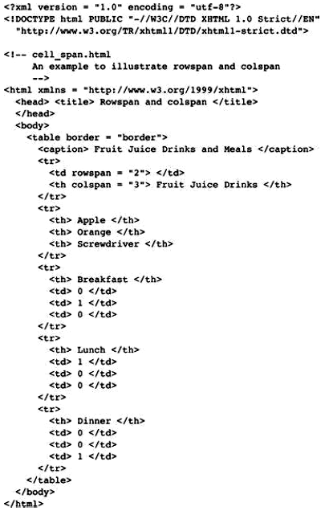
Figure 19 shows a browser display of cell_span.html.
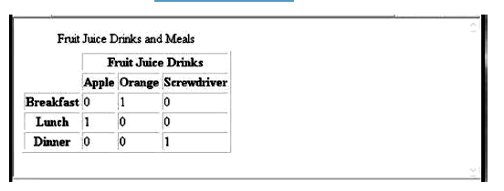
Figure 19 Display of cell_span.html: multiple-labeled columns and labeled rows

6.3- The align and valign Attributes
The placement of the content within a table cell can be specified with the align and valign attributes in the <tr>, <th>, and <td> tags. The align attribute has the possible values left, right, and center, with the obvious meanings for horizontal placement of the content within a cell. The default alignment for the cells is center; for td cells, it is left. If align is specified in a <tr> tag, it applies to all of the cells
in the row. If it is included in a <th> or <td> tag, it applies only to that cell.
The valign attribute of the <th> and <td> tags has the possible values top and bottom. The default vertical alignment for both headings and data is center. Because valign applies only to a single cell, there is never any point in specifying center.The following example illustrates the align and valign attributes:
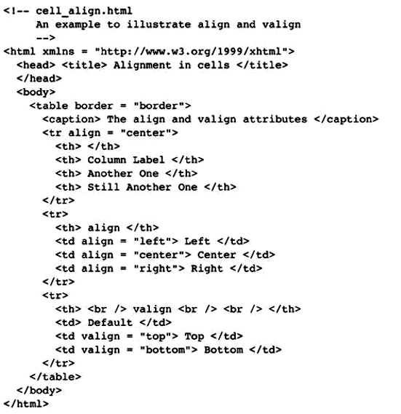
Figure 20 shows a browser display of cell_align.html.
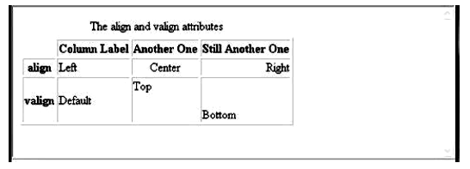
Figure 20 Display of cell_align.html: the align and valign attributes

6.4 The cellpadding and cellspacing Attributes
The table tag has two attributes that can respectively be used to specify the spacing between the content of a table cell and the cell’s edge and the spacing between adjacent cells. The cellpadding attribute is used to specify the spacing between the content of a cell and the inner walls of the cell—often, to prevent text in a cell from being too close to the edge of the cell. The cellspacing attribute is used to specify the distance between cells in a table. The following document, space_pad.html, illustrates the cellpadding and cellspacing attributes:
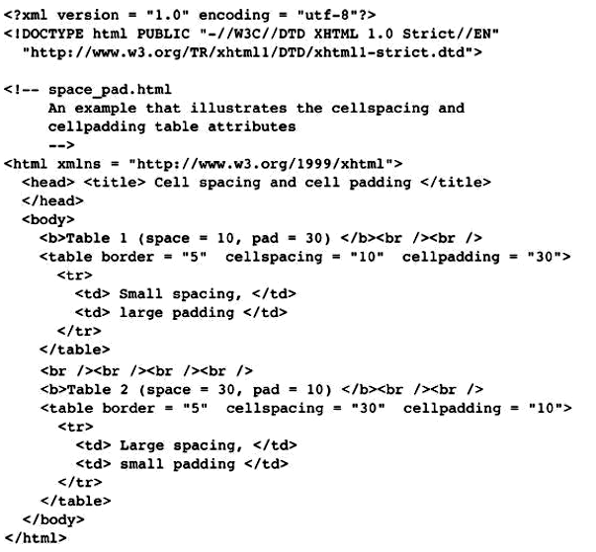
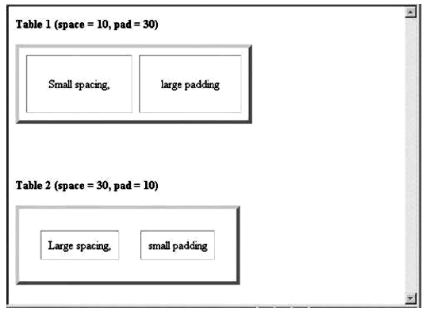
Figure 21 Display of space_pad.html

6.5 Table Sections
Tables naturally occur in two and sometimes three parts: header, body, and footer. (Not all tables have a natural footer.) These three parts can be respectively denoted in XHTML with the thead, tbody, and tfoot elements. The header includes the column labels, regardless of the number of levels in those labels. The body includes the data of the table, including the row labels. The footer, when it appears, sometimes has the column labels repeated after the body. In some tables, the footer contains totals for the columns of data above. A table can have multiple body sections, in which case the browser may delimit them with horizontal lines that are thicker than the rule lines within a body section.

7- Forms
The most common way for a user to communicate information from a Web browser to the server is through a form. Modeled on the paper forms that people frequently are required to fill out, forms can be described in XHTML and displayed by the browser. XHTML provides tags to generate the commonly used objects on a screen form. These objects are called controls or widgets. There are controls for single-line and multiple-line text collection, checkboxes, radio buttons, and menus, among others. All control tags are inline tags. Most controls are used to gather information from the user in the form of either text or button selections. Each control can have a value, usually given through user input. Together, the values of all of the controls (that have values) in a form are called the form data.

7.1 The <form> Tag
All of the controls of a form appear in the content of a <form> tag. A block tag, <form>, can have several different attributes, only one of which, action, is required. The action attribute specifies the URL of the application on the Web server that is to be called when the user clicks the Submit button. In this note, our examples of form elements will not have corresponding application programs, so the value of their action attributes will be the empty string ("").
The method attribute of <form> specifies one of the two techniques, get or post, used to pass the form data to the server. The default is get, so if no method attribute is given in the <form> tag, get will be used. The alternative technique is post. In both techniques, the form data is coded into a text string when the user clicks the Submit button. When the get method is used, the browser attaches the query string to the URL of the HTTP request, so the form data is transmitted to the server together with the URL. The browser inserts a question mark at the end of the actual URL just before the first character of the query string so that the server can easily find the beginning of the query string. The get method can also be used to pass parameters to the server when forms are not involved. (This cannot be done with post.) One disadvantage of the get method is that some servers place a limit on the length of the URL string and truncate any characters past the limit.
So, if the form has more than a few controls, get is not a good choice. When the post method is used, the query string is passed by some other method to the form processing program. There is no length limitation for the query string with the post method, so, obviously, it is the better choice when there are more than a few controls in the form. There are also some security concerns with get that are not a problem with post.

7.2 The <input> Tag
Many of the commonly used controls are specified with the inline tag <input>, including those for text, passwords, checkboxes, radio buttons, and the action buttons Reset, Submit, and plain.
The one attribute of <input> that is required for all of the controls discussed in this section is type, which specifies the particular kind of control. The control’s kind is its type name, such as checkbox. All of the previously listed controls except Reset and Submit also require a name attribute, which becomes the name of the value of the control within the form data. The controls for checkboxes and radio buttons require a value attribute, which initializes the value of the control. The values of these controls are placed in the form data that is sent to the server when the Submit button is clicked.
A text control, which we usually refer to as a text box, creates a horizontal box into which the user can type text. Text boxes are often used to gather information from the user, such as the user’s name and address. The default size of a text box is often 20 characters. Because the default size can vary among browsers, it is a good idea to include a size on each text box. This is done with the size attribute of <input>. If the user types more characters than will fit in the box, the box is scrolled. If you do not want the box to be scrolled, you can include the maxlength attribute to specify the maximum number of characters that the browser will accept in the box. Any additional characters are ignored. As an example of a text box, consider the following:
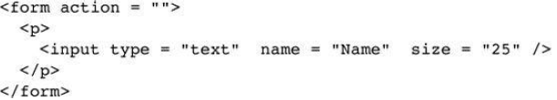
Suppose the user typed the following line:

Alfred Paul von Frickenburger

The text box would collect the whole string, but the string would be scrolled to the right, leaving the following shown in the box:

ed Paul von Frickenburger

The left end of the line would be part of the value of Name, even though it does not appear in the box. The ends of the line can be viewed in the box by moving the cursor off the ends of the box. Notice that controls cannot appear directly in the form content—they must be placed in some block container, such as a paragraph. This is because <input> is an inline tag. Now consider a similar text box that includes a maxlength attribute:
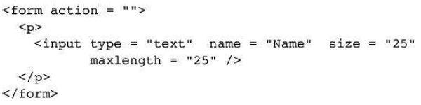
If the user typed the same name as in the previous example, the resulting value of the Name text box would be as follows:

Alfred Paul von Frickenbu

No matter what was typed after the u in that person’s last name, the value of Name would be as shown. If the contents of a text box should not be displayed when they are entered by the user, a password control can be used as follows:
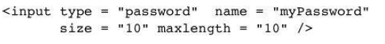
In this case, regardless of what characters are typed into the password control, only bullets or asterisks are displayed by the browser. There are no restrictions on the characters that can be typed into a text box. So, the string “?!34,:” could be entered into a text box meant for names. Therefore, the entered contents of text boxes nearly always must be validated, either on the browser or on the server to which the form data is passed for processing, or on both.
Text boxes, as well as most other control elements, should be labeled. Labeling could be done simply by inserting text into the appropriate places in the form:

Phone: <input type = “text” name = “phone” />

This markup effectively labels the text box, but there are several ways the labeling could be better. For one thing, there is no connection between the label and the control. Therefore, they could become separated in maintenance changes to the document. A control and its label can be connected by putting the control and its label in the content of a label element, as in the following element: <label> Phone:

<input type = “text” name = “phone” />
</label>

Now the text box and its label are encapsulated together. There are several other benefits of this approach to labeling controls. First, browsers often render the text content of a label element differently to make it stand out. Second, if the text content of a label element is selected, the cursor is implicitly moved to the control in the content of the label. This feature is an aid to new Web users. Third, the text content of a label element can be rendered by a speech synthesizer on the client machine when the content of the label element is selected. This feature can be a great aid to a user with a visual disability. Checkbox and radio controls are used to collect multiple-choice input from the user. A checkbox control is a single button that is either on or off (checked or not). If a checkbox button is on, the value associated with the name of the button is the string assigned to its value attribute. A checkbox button does not contribute to the form data if it is off. Every checkbox button requires a name attribute and a value attribute in its <input> tag. For form processing on the server, the name identifies the button and the value is its value (if the button is checked). The attribute checked, which is assigned the value checked, specifies that the checkbox button is initially on. In many cases, checkboxes appear in lists, with every one in the list having the same name. Checkbox elements should appear in label elements, for the same reasons that text boxes should. The following example illustrates a checkbox:
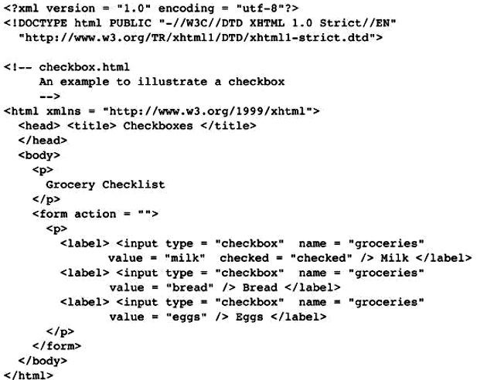
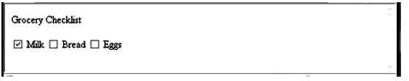
Figure 22 Display of checkbox.html
If the user does not turn on any of the checkbox buttons in our example, milk will be the value for groceries in the form data. If the milk checkbox is left on and the eggs checkbox is also turned on by the user, the values of groceries in the form data would be milk and eggs. Radio buttons are closely related to checkbox buttons. The difference between a group of radio buttons and a group of checkboxes is that only one radio button can be on or pressed at any time. Every time a radio button is pressed, the button in the group that was previously on is turned off. Radio buttons are named after the mechanical push buttons on the radios of cars of the 1950s—when you pushed one button on such a radio, the previously pushed button was mechanically forced out. The type value for radio buttons is radio. All radio buttons in a group must have the name attribute set in the <input> tag, and all radio buttons in a group must have the same name value. A radio button definition may specify which button is to be initially in the pressed, or on, state. This specification is indicated by including the checked attribute, set to the value checked, in the <input> tag of the button’s definition. If no radio button in a group is specified as being checked, the browser usually checks the first button in the group. The following example illustrates radio buttons:
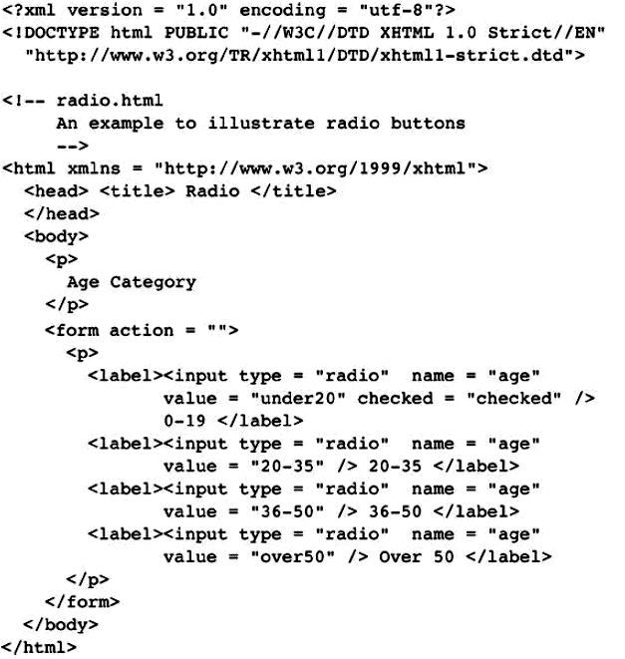
Figure 23 shows a browser display of radio.html.
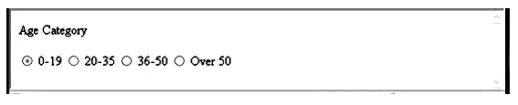
Figure 23 Display of radio.html
7.3 The <select> Tag
Checkboxes and radio buttons are effective methods for collecting multiple-choice data from a user. However, if the number of choices is large, the form becomes too long to display. In these cases, a menu should be used. A menu is specified with a <select> tag (rather than with the <input> tag). There are two kinds of menus: those in which only one menu item can be selected at a time (which are related to radio buttons) and those in which multiple menu items can be selected at a time (which are related to checkboxes). The default option is the one related to radio buttons. The other option can be specified by adding the multiple attribute, set to the value “multiple”. When only one menu item is selected, the value sent in the form data is the value of the name attribute of the <select> tag and the chosen menu item. When multiple menu items are selected, the value for the menu in the form data includes all selected menu items. If no menu item is selected, no value for the menu is included in the form data. The name attribute, of course, is required in the <select> tag. The size attribute, specifying the number of menu items that are to be displayed for the user, can be included in the <select> tag. If no size attribute is specified, the value 1 is used. If the value for the size attribute is 1 and multiple is not specified, just one menu item is displayed, with a downward scroll arrow. If the scroll arrow is clicked, the menu is displayed as a pop-up menu. If either multiple is specified or the size attribute is set to a number larger than 1, the menu is usually displayed as a scrolled list.
Each of the items in a menu is specified with an <option> tag, nested in the select element. The content of an <option> tag is the value of the menu item, which is just text. (No tags may be included.) The <option> tag can include the selected attribute, which specifies that the item is preselected. The value assigned to select is “selected”, which can be overridden by the user. The following document describes a menu with the default value (1) for size:
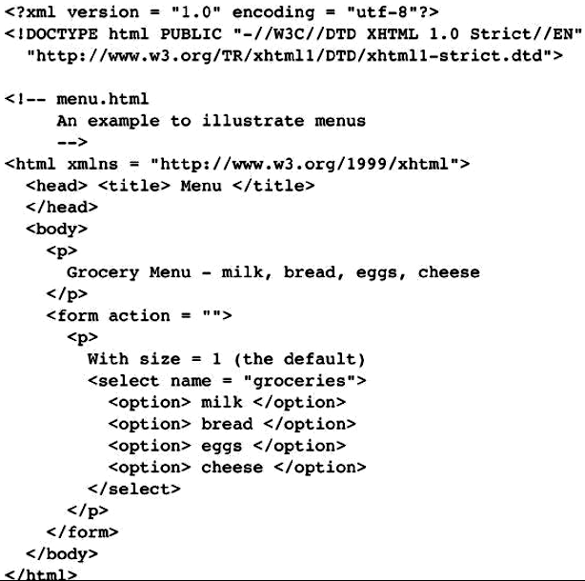
Figure 24 shows a browser display of menu.html. Figure 25 shows a browser display of menu.html after clicking the scroll arrow. Figure 26 shows a browser display of menu.html after modification to set size to “2.”
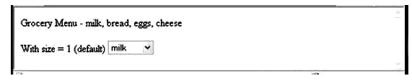
Figure 24 Display of menu.html (default size of 1)

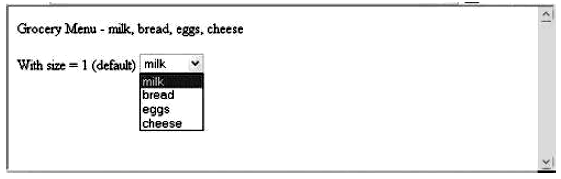
Figure 25 Display of menu.html after the scroll arrow is clicked
Figure 26 Display of menu.html with size set to 2
When the multiple attribute of the <select> tag is set, adjacent options can be chosen by dragging the mouse cursor over them while the left mouse button is held down. Nonadjacent options can be selected by clicking them while holding down the keyboard Control key.

7.4 The <textarea> Tag
In some situations, a multiline text area is needed. The <textarea> tag is used to create such a control. The text typed into the area created by <textarea> is not limited in length, and there is implicit scrolling when needed, both vertically and horizontally. The default size of the visible part of the text in a text area is often quite small, so the rows and cols attributes should usually be included and set to reasonable sizes. If some default text is to be included in the text area, it can be included as the content of the text area element. The following document describes a text area whose window is 40 columns wide and three lines tall:
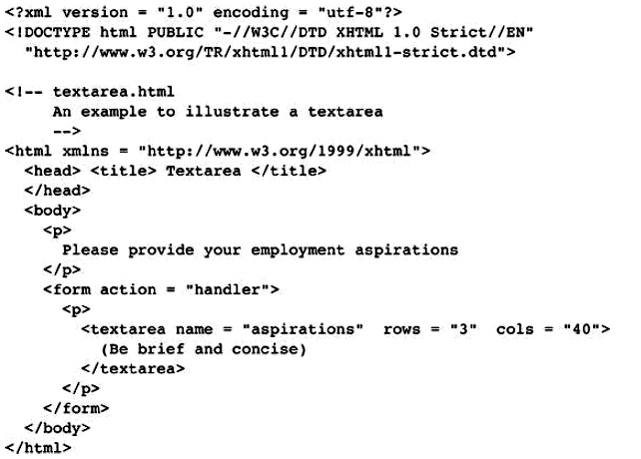
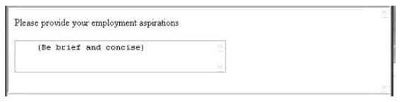
Figure 27 Display of textarea.html after some text entry
7.5 The Action Buttons
The Reset button clears all of the controls in the form to their initial states. The Submit button has two actions: First, the form data is encoded and sent to the server; second, the server is requested to execute the server-resident program specified in the action attribute of the <form> tag. The purpose of such a server-resident program is to process the form data and return some response to the user. Every form requires a Submit button. The Submit and Reset buttons are created with the <input> tag, as shown in the following example:
<form action = ““>
<p>
<input type = “submit” value = “Submit Form” />
<input type = “reset” value = “Reset Form” />
</p>
</form>

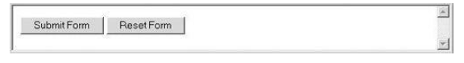
A plain button has the type button. Plain buttons are used to choose an action.

7.6 Example of a Complete Form
The document that follows describes a form for taking sales orders for popcorn. Three text boxes are used at the top of the form to collect the buyer’s name and address. These boxes are placed in a borderless table to force them to align vertically. A second table is used to collect the actual order. Each row of this table names a product with the content of a <td> tag, displays the price with another <td> tag, and uses a text box with size set to 2 to collect the quantity ordered. The payment method is input by the user through one of four radio buttons. Notice that none of the input controls in this document are embedded in label elements. This is because table elements cannot be labeled, except by using the row and column labels. Tables present special problems for the visually impaired. The best solution is to use style sheets instead of tables to lay out tabular information.
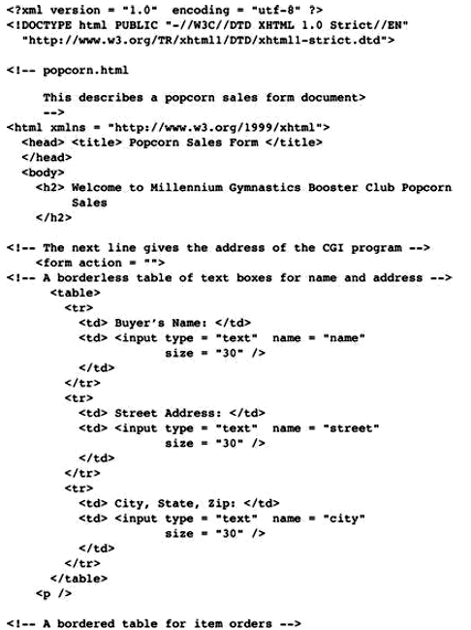
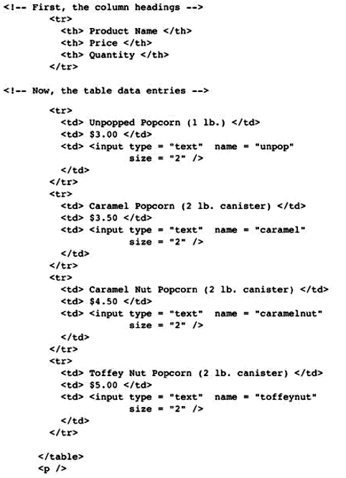
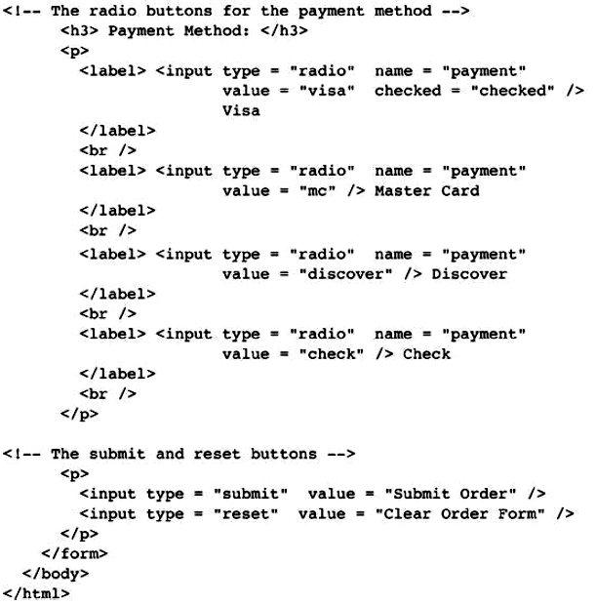
Figure 29 shows a browser display of popcorn.html.
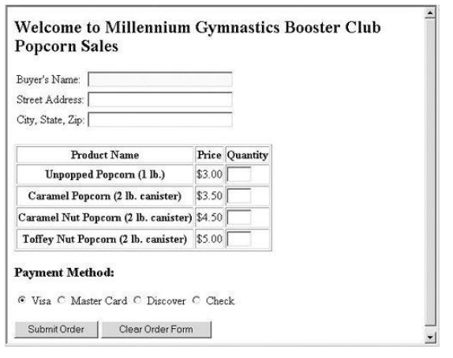
Figure 29 Display of popcorn.html

Exercises
1- Create, test, and validate an XHTML document for yourself, including your name, address, and e-mail address. If you are a student, you must include your major and your grade level. If you work, you must include your employer, your employer’s address, and your job title. This document must use several headings and <em>, <strong>, <hr />, <p>, and <br /> tags.

2- Add pictures of yourself and at least one other image (of your friend, spouse, or pet) to the document created for Exercise 1.

3- Add a second document to the document created for Exercise 1 that describes part of your background, using background as the link content. This document should have a few paragraphs of your personal or professional history.

4- Create, test, and validate an XHTML document that describes an unordered list equivalent to your typical grocery shopping list. (If you’ve never written a grocery list, use your imagination.)

5- Create, test, and validate an XHTML document that describes an unordered list of at least four states. Each element of the list must have a nested list of at least three cities in the state.
6- Create, test, and validate an XHTML document that describes an ordered list of your five favorite movies.

7- Modify the list of Exercise 6 to add nested, unordered lists of at least two actors and/or actresses in your favorite movies.
8- Create, test, and validate an XHTML document that describes an ordered list with the following contents: The highest level should be the names of your parents, with your mother first. Under each parent, you must have a nested, ordered list of the brothers and sisters of your parents, in order by age, eldest first. Each of the nested lists in turn must have nested lists that list the children of your uncles and aunts (your cousins)—under the proper parents, of course. Regardless of how many aunts, uncles, and cousins you actually have, there must be at least three list items in each sublist below each of your parents and below each of your aunts and uncles.

9- Create, test, and validate an XHTML document that describes a table with the following contents: The columns of the table must have the headings “Pine”, “Maple”, “Oak”, and “Fir”. The rows must have the labels “Average Height”, “Average Width”, “Typical Life Span”, and “Leaf Type”. You can make up the data cell values.

10- Modify, test, and validate an XHTML document from Exercise 9 that adds a second-level column label, “Tree”, and a second-level row label, “Characteristics”.

11- Create, test, and validate an XHTML document that defines a table with columns for state, state bird, state flower, and state tree. There must be at least five rows for states in the table. You must include attribute specifications for cellpadding and cellspacing.

12- Create, test, and validate an XHTML document that defines a table with two levels of column labels: an overall label, “Meals”, and three secondary labels, “Breakfast”, “Lunch”, and “Dinner”. There must be two levels of row labels: an overall label, “Foods”, and four secondary labels, “Bread”, “Main Course”, “Vegetable”, and “Dessert”. The cells of the table must contain a number of grams for each of the food categories.

13- Create, test, and validate an XHTML document that is the home page of a business, Tree
Branches, Unlimited, that sells tree branches. This document must include images and descriptions of at least three different kinds of tree branches. There must be at least one unordered list, one ordered list, and one table. Detailed descriptions of the different branches must be stored in separate documents that are accessible through links from the home document. You must invent several practical uses for tree branches and include sales pitches for them.

14- Create, test, and validate an XHTML document that has a form with the following controls:
a. A text box to collect the user’s name
b. Four checkboxes, one each for the following items:
i. Four 100-watt light bulbs for $2.39
ii. Eight 100-watt light bulbs for $4.29
iii. Four 100-watt, long-life light bulbs for $3.95
iv. Eight 100-watt, long-life light bulbs for $7.49
c. A collection of three radio buttons that are labeled as follows:
i. Visa
i. Visa
ii. Master Card
iii. Discover

