Use input boxes Input Box

یstdechm This type of functions To take Information from the user where this type of function displays a message as well as a group of the Controls affiliates.
- The dialog box that is using components of display it Input Box

Message -1 Namely the message that یardھa user.

-2 Text Box Text Box and usesLaddFree data in it.

-3 button ok

-4 button . Cancel

It is obtained in response to the user by pressing a button Ok or Cancel button

The general shape of this function:

str_var = InputBox (prompt, [title], [default], [x_pos], [y_pos])

Prompt -1 represents the literal text that reflects the message that we want to view.

Title -2 represents the title of Dialog Box Oھo optional.

Default 3. represents the literal text that we want vulnerable inside the box Oھo optional.

x_pos -4 represents the location ofNoTread, which will appear by the . Input Box

y_pos-5 represents the vertical location that will appear on. Input Box

Example : Designed window containing a list box and buttons is then type software code to enable the user to do the following:

-1 buttonthe motherRthe first View user information to enable that have been entered into the list by the Fund Fund ExceptIncome.

-2 ButtonExceptOver the second to enable the user to scan the information that has been pre-entered after the message appears to confirm the request of the survey.

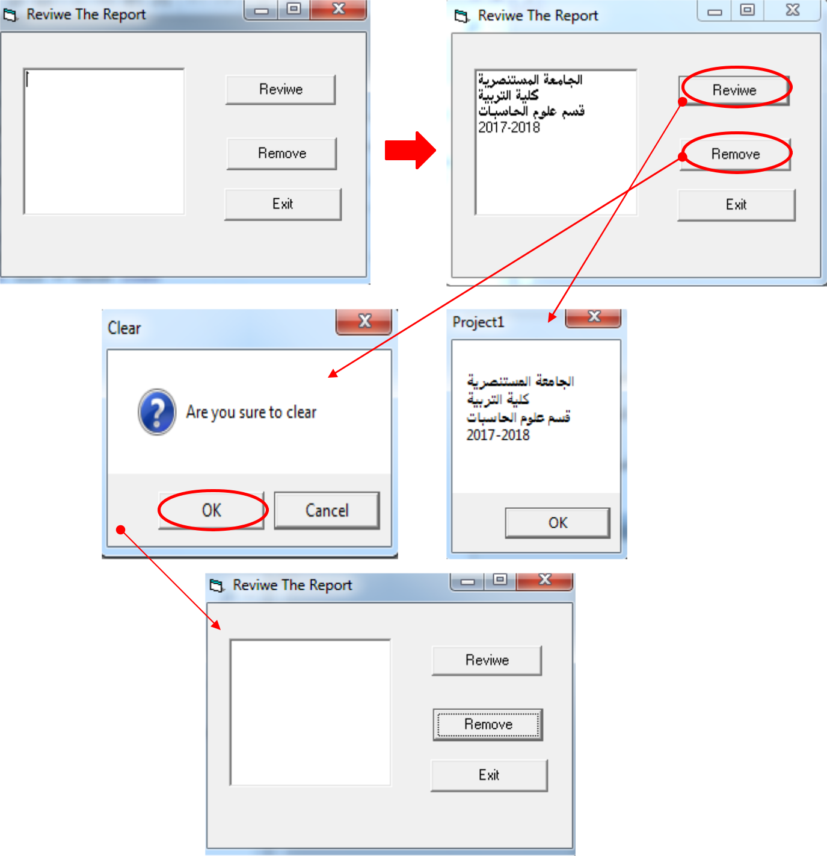

Assigment: Write a VB program according to the following GUI

