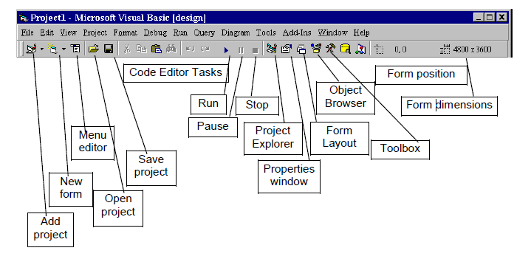

Figure 5: Tool Bare

Address bar Titel Bar

Window Project Explorer Project Explorer Window

Located in the default situation in the upper right corner of the window Alfjwal Basic and are bearing the name Project value plus the current name of the project, the following figure shows this window in detail:
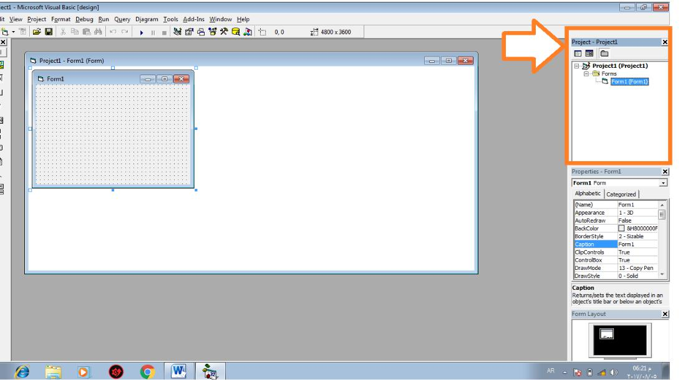

Figure 6: Project Explorer

These displays projects with all its contents window in the form of a tree representing each project root key of this tree, while the show files Forms where the shape of the branches of this tree. Window Project Explorer contains three buttons) (Items shown namely in Figure 7:

- : Toggle Folder that are home to this injunction to change the style of display objects Objects in the window.

- : View Object that is the home to this Instruct demonstrate the interface visual model and all of the controls placed on it.

- : View Code that are home to this Instruct demonstrate blade model code and all of the controls placed on it, and the following figure shows the elements of the Project Explorer window:
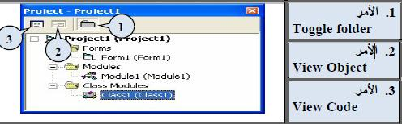

Figure 7: Project Explorer Elements

aModel Form

Considered the model is the essential element in all applications Alfjwal Basic, appears in the middle of the screen is almost used to design and interfaces program where placed by all the tools used (tools, writing, code, images, etc.) The program contains one or more of these models, help points appears inside the form on the design of the interface and control tools and sites of different elements.

The following figure shows the model window Form1 in this window can change the measurement model by moving the mouse over one of the eight squares around the model until it changes Hklھa to share double-headed, push mouse button left and pull with continued pressure until we get the desired measurement you .یkdm A Visual Basic tool that helps you define measurement model namely measurement box object object Size box that appears in the far right of the toolbar .یbیn this fund width and height of the model Oھo shown in the right of the following figure, while the image on the left Tosah model window with serial code:

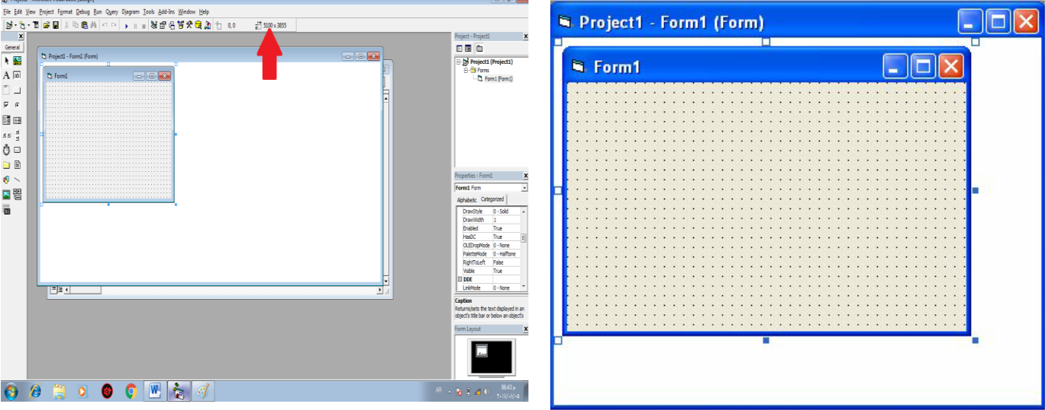

Figure 8: The Form1

Properties window Properties Window

Namely the properties that belong to a group or object model exists in a specific design environment. The properties are a set of variables associated with the item and control these variables or characteristics in the appearance of the item or object. ھnalk are some characteristics of an amendment for in the implementation phase and some in the other phases (phases of the design and implementation).

To change any property of xNoFor this window appears on the form or their effect controls on it, for example, we can change the dimensions of the model change the Kasiti Width and Height as well as determine the location of the model when implementation through Kasiti Top and Left properties arranged either alphabetically or on a Alphabetic totals .Categorized form
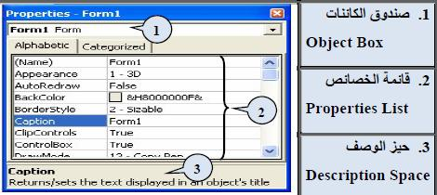

Figure 9: Form Propertise

It is possible to change some of the attributes of the object Form in terms of the nature of color, name, or the color of the floor ... etc. through this window and Joasھa multiple.

For example, if we want to change the inclusion of an image in the ground form we follow the following shortcut:

Appearance - Picture - Select your image - Open.
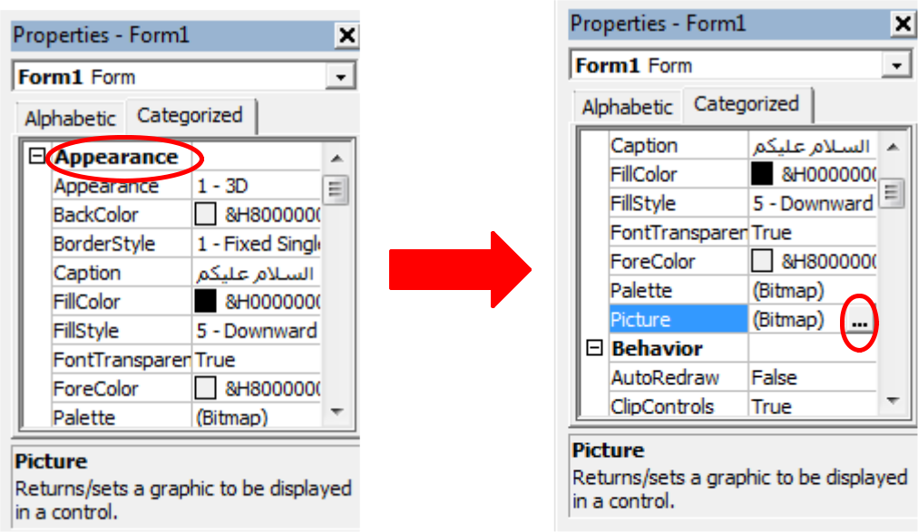

Figure 10: Chage Form Bechgruond

This window consists of three main parts:

- Object Box included the name of the form and elements on it

- List Properties List the characteristics of the model or one of its components

- Description Space provides a brief explanation about the specific feature

  - Model diagram window Form Layout

This enables us to determine the window of the location of the model when implemented this window appears where all the models that یtdmnھa the project so that the chosen floats in front of the model and the rest of the models with his name and change the location of the model we'll just click it and drag it to the new location.

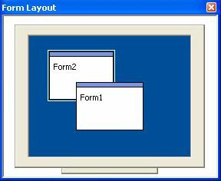

Figure 11: Form Layout

Razor Screen Code Window

You used to write the program through the definition of variables and user-defined programs. The first sub line of code Code words starts and Private sub یtbaھa name of the item or the tool, and the event under which it will work or tool element either the last line of code is a Vھa End sub can not be without any tool of these two sentences never.
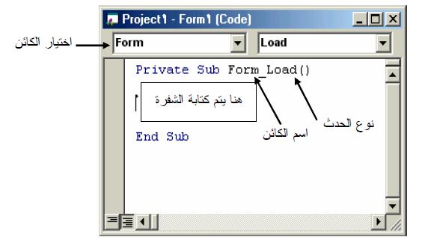

Figure 12: Code Windwo

We can demonstrate the code window to one of two ways:

- Through the window of the Project Explorer Project Explorer Window by clicking on the custom button Zھar window code as mentioned in the above.

- Double-clicking the left button of the mouse on the object that we want to display the code for

How to write the code

Double-click on the item that we want in writing the code for:
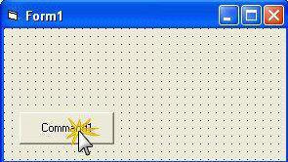

Vtzھr Alhvrh- window:

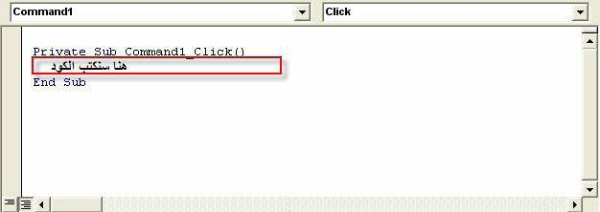

Figure 14: The Code Structure

The first configuration program:

- Add a command button Command Button The title tool Label On the form . Form

2. Double-click on the form to write the following code:

Private Sub Form_Load ()
Label1 .Caption = "Visual Basic"

Command1.Caption = "End"
End Sub

Back to the model and double click on the command button to write the following code:

Private Sub Command1_ Click ()

End

End Sub
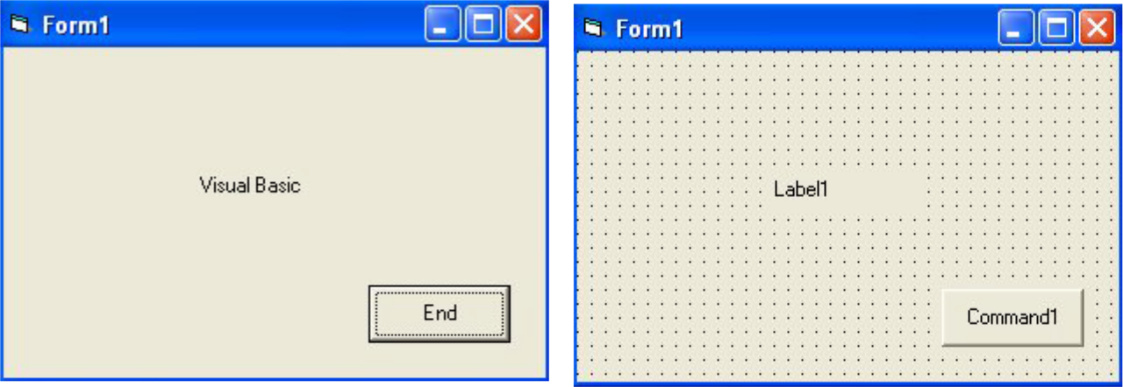

Figure 14: Run the Program

Discussion-:

- After identifying the elements of the design environment tools close the box and then all the windows and then looking for Alaیkonat and commands that re-Vthھa.

- Add tools to the form and then select the shared Bیnھa properties.

