Box tools Tool Box

It includes a set of tools that facilitate dealing with Visual Basic used in the preparation of programs and tools can be transferred to the fund anywhere within the screen, which are easy to deal with him and with the rest of the tools screen elements .
.

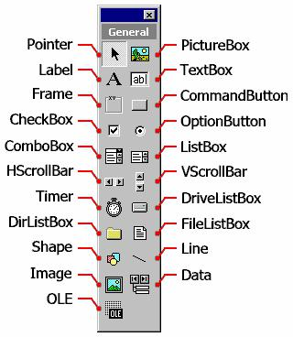

- Cursor Pointer is used to select tools and other controls.

- Picture Box Picture box to display images

- Title tool Label to display addresses within the form.

- Text Box Text Box Text enter Awale

- the frame Frame is used to select a set of tools within the framework of one.

- Button commands Command Button is can be performed from, during which many applications.

- Examination Fund Check Box displays several boxes checked and allows the user to select one or a group of data selection by the user need.

- Radio button Option Button is used when intended to offer a range of alternatives and allow the user the option of only one.

- Narrative and dialogue tool Combo Box and is used to store data list Drop Down list

- List Box List Box is used when the data to be stored in the list. 11. bar rolling horizontal Horizontal Scrollbar puppies move horizontally.
  - Vertical bar rolling Vertical Scrollbar puppies move vertically.

  - Timer Timer to perform an action at a certain given time.

  - List CD Box Drive List Box is used to display a list of all disks on the device.

  - List the names Alvھars Fund Dir List Box) is used to display a list of names of Alvھars that یhtoیھa disk

  - List the names of the files box File List Box is used to display a list of files that یhtoیھa Alvھrs.

- Tool formats Shape to draw shapes ھndsیh specific

Line 18. Line tool to draw a line on the form.

  - Image tool Image tool box similar to the image Knھa features holograms extension Stretch

  - Databases Data is used to connect with databases.

- Linking and Embedding tool OLE to link with other programs.

Programming language Alfjwal Basic:

It is a visual programming of the most important advantages in Alfjwal Basic and that made it Mnھ a powerful and effective project development, as it is done part of a good Bھ of work by adding models and controls to the project and change the dimensions and appearance of these elements to be ultimately INTERFACE application attractive and effective at the same time that the process of adding windows and controls alone are not enough to make a useful application, as you must add the code code to complete the work application. And the code are a set of directives that define the computer what to do and is usually linked to this code by events Event which represents the spark that incite the program to work, as happens when you click on a button or change the measurement of a window.

Example: 1

Our window Form1 containing two controls on Bdakhlھa Command Button type as in the following figure:
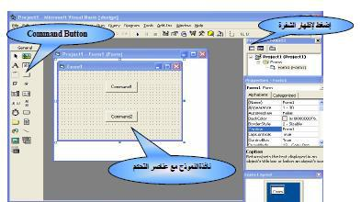

To view the code Bھma form we click on the button View Code in the Project Explorer window
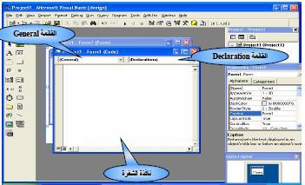

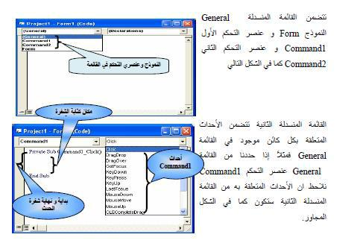

Here we notice that the control Command1 group of events and that each event of these events, the software code for the Bھa as Alfjwal Basic by typing the beginning and end of the event code automatically and programmed between them can write code that wish to implement when the event occurs. It should be noted that it is possible to write code for several events and a control one as in the following figure:
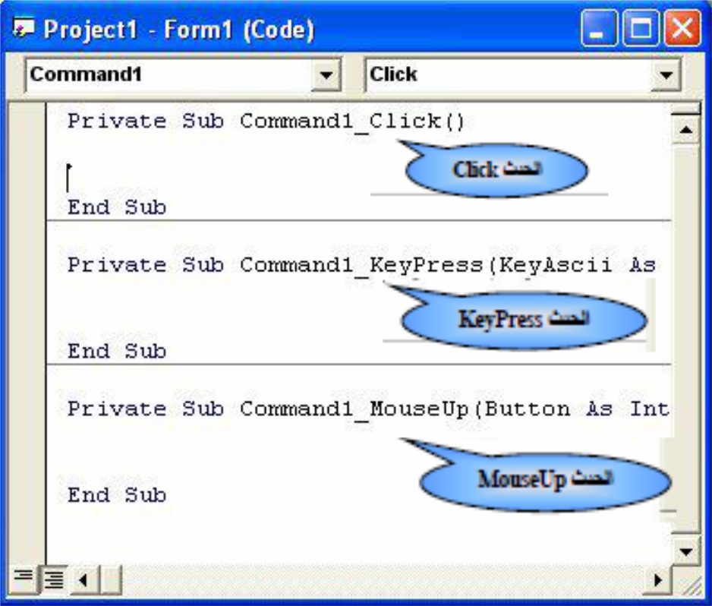

Reference to the forms and controls of the code software : (Code)

Of good habits that used by many programmers use the prefix consisting of three letters, which reflects the element type when you call it The following are prefixes Alhھیrh different elements you are using : Visual Basic
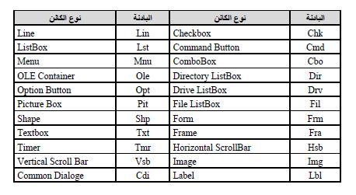

Adjust the tools properties:

It is read and adjust the property values ​​just as we do with variables Variables can be used in comparison or calculations or phrases to use the term allocation which there Assignment Bھa = scientist to determine the value of a property. When using the label semicolons you want to refer to one of the properties, and that you want to refer to another window reduction feature objects put the name of the window at the beginning, which means that the general formula of poison feature

FormName.ObjectName.PropertyName:

The process of adjusting the control properties through the properties window or the code as the code shown in the following figure:
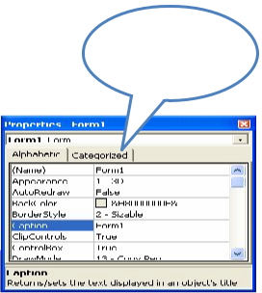

It is selected properties

To be changed Mnnavzh characteristics

And it is assigning value of new Lھa
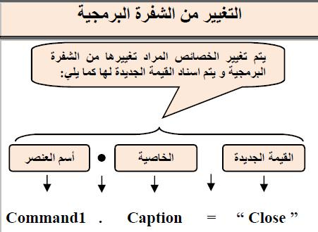

Some non ھnalk properties are available during operation or be read only during operation and others are available only during operation and is not available during design, it is always advisable to mention the name of feature during the reference Alیھa but Visual Basic Understand the specific properties on the virtual element they are reported automatically certain that did not mention another property after the name of the item ObjectName example feature is the Caption feature is the default title of the Label wrote Label1 solo was Manaھa .Label1.Caption The following table shows the default characteristics of the basic instruments:
