♦ (Commands Buttons)

Event must use the starch in the program Maljth Oھo of the most frequently used elements:
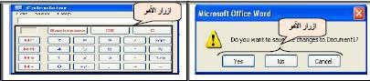

The most important events associated with it:

- Click

- Caption

- Enabled

Characteristics related to Baobaad:

- Height, Width

- Top, Left

  - Characteristics of the writing style : Font

  - Color feature back Back Color

Click

The most important characteristics of the command buttons Command Button

Button has many of the terminal, the software features that can be Ngیrھa manually through software to perform blond as its work is required. We will focus on the most important characteristics regarding the use of command buttons.

- Name

This feature is used to change the real name of the item code which is written in the illustration only, without the apparent change the name Caption element on the form .یtm resort to change this feature to simplify the code reading software for the collection of items on the form.

Possible property change Name is only one:

Changed manually through the properties window of the same element as follows:
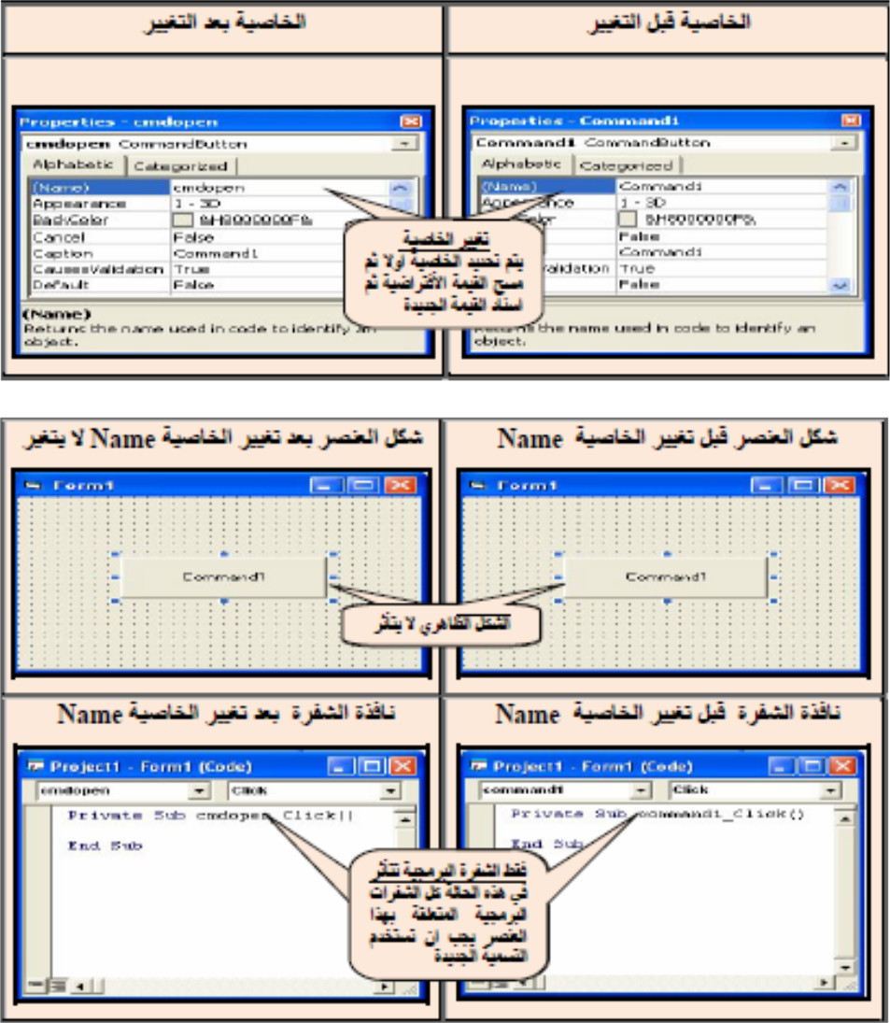

Luck to change this feature does not change the label Zaھrیh of Anasraly model, but changes the designation of the element that appears in the code window .kzlk can not be changed this feature through the code code as is the case in most of the properties and if we tried to change this feature through the code software will appear the program message error after the implementation of the program as shown in the following figure (try to change this feature of the code in the lab and you'll get the same output).

Note: - care must be taken that the property change Name element specific to the designation of a new, all codes related to the code Bھma element should be used as the label of the new.
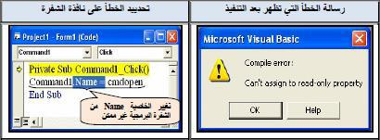

This message means and can not assign property value that it is possible to read it only. Any programmer Bomkanھ to read this feature without changed.

Example: 2 designed window containing elemental type command button control when you click on any Mnھma prints property value Name of him on the form (non-feature Name the second element to be. (CMD
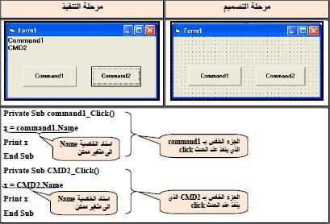

Page

Source code

Private Sub command1_ Click ()
x = command1.Name
Print x
End Sub

Private Sub Command2_ Click ()
x = Command2.Name
Print x
End Sub

Caption

This feature is used to give a virtual button and terminal, it must be expressed as much as possible for the title of the work done by that element. The label is the automatic terminal, buttonCommandAnd it is attached to the sequence button on the form as Malhz that this gives the idea of ​​naming the user about the work associated Bھma button. Possible property changeCaption two modes manually changed through the properties window of the same element as follows:
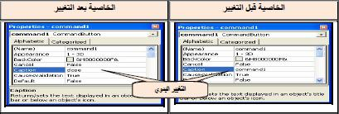

Also you can change this feature of the code through the code through the following statement:

Command1 .Caption = "The new name"

Note:

  - : Command1 by the variable botton

- : Caption the constant is changing

- : "The new name" variable according to the name assigned to the botton Bھma

Example3:Designed window containing a single control typecommand button when you click it changes the value of the property model Caption (Fram (a new name is .Save
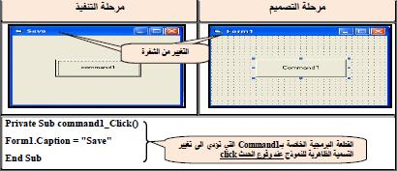

Source code:

Private Sub command1_ Click ()

Form1.Caption = "Save"
End Sub

Try a piece with the following code:

Source code:

Private Sub command1_ Click ()
Form1.Caption = "Save"
Command1.Caption = "END"

End Sub

Caption will change the label Zaھrیh control only without the label that appears in the code programming luck the following figure:
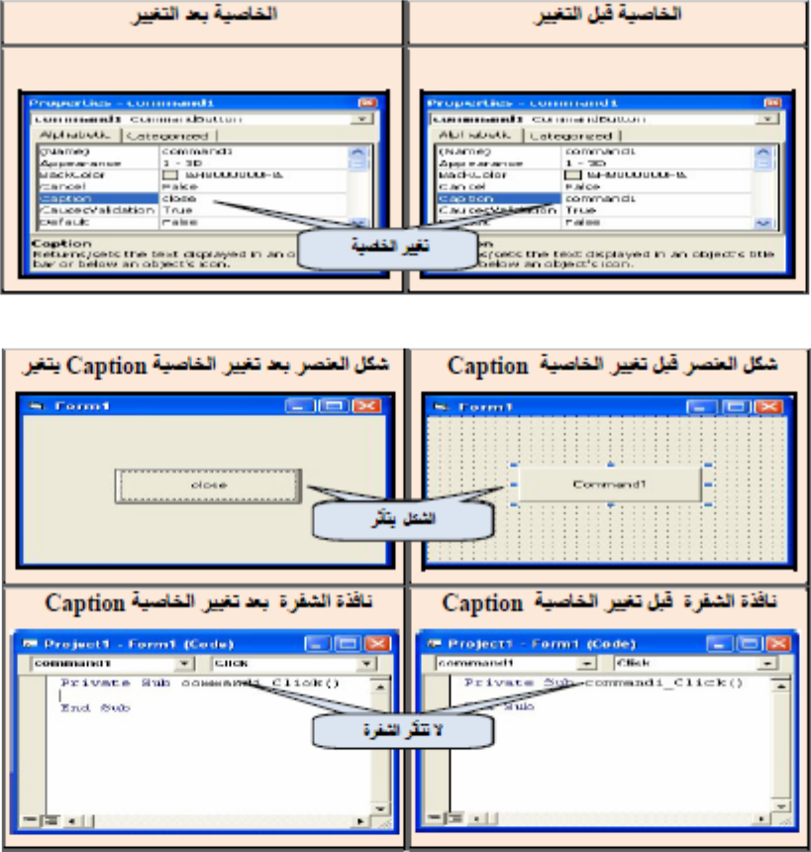

: Enabled

This feature is used to enable the terminal, button on the form or not to enable it to perform assigned work where the event takes this feature one of two True or False

Value True enables the control of the work element is implementation of the program code associated with it when the event occurs), namely value default (.

Value False mastery of the essential element control work and be associated with the implementation of the program code when the event occurs and یdھr is an ineffective control.

Possible property change Enabled in two (manually changed through the properties window of the same element (as follows
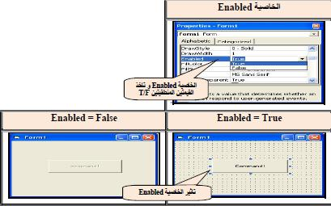

Command1. Enabled = True \ False

Example: a window containing a single control type ) Command Button (, when clicked one click not be effective when clicked becomes effective a couple Mttalیtaatیn) double click (.
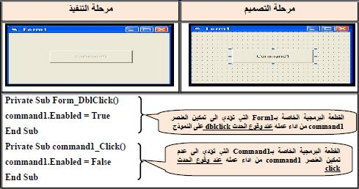

Source Code:

Private Sub Form_DblClick ()

command1.Enabled = True
End Sub
Private Sub command1_ Click ()
command1.Enabled = False
End Sub

.4 characteristics related Baobaad:

There are four characteristics to change the dimensions of the special location and size of the control element added to the form, and are:

Height, Width Define the dimensions of the control

Top, Left Define the control site for the model as یodhھa follows:
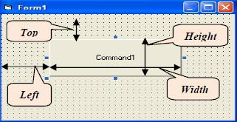

Possible to change these characteristics in two changed manually through the properties window of the same element by selecting each of these characteristics and the development of the value of digital L through the code code:

Numeric value Command1.Width =

Numeric value Command1.Height =

Numeric value Command1.Top =

Numerical value Command1.Left =

Example: -4 Designed window containing the elemental type of control command button Different-dimensional work as follows: When you Once on the first item becomes item location in the upper left corner of the form either when you click on the second control becomes nominally equal element of the first control.
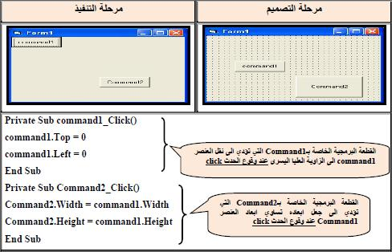

5.Characteristics of the writing style : Font

Property determines Font Writing in the pattern on the control in terms of font, font size and Mیalnh and fish species it is possible to change the characteristics of these two ways:

- Changed manually through the properties window of the same item so choose feature Font When you click on the box next Lھa Stdھr our window we define as the style of writing, during which is shown in the following figure:

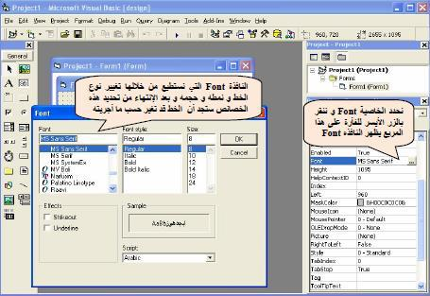

2. Oongییrھa through the code code:
Writes the font type | Command1.Font = "times new roman"
True OR False | Command1.FontBold = True
True OR False | Command1.FontItalic = True
Numeric value | Command1.FontSize = 20
True OR False | Command1.FontUnderline = True

Example5:Designed window containing four elements of the type of controlcommand button to do the following:

- Feature Caption for the first element to be UOT-EEED immediately after the implementation of the program

- The second control makes the phrase written on the first line element Dark

- The third control makes the phrase written on the first line element italic

- Fourth control makes the phrase written on the first line of the size of the element 20

.6 Color feature back Back Color

Determines the background color of the element Command Button and many other elements namely here to be with the syndrome Style feature which sets the pattern where you must button terminal, to be recognized at .1-Graphica

It is possible to change this feature Back Color Manually (through the properties window (or through the code code:

Command1.BackColor = vbRed

Command1.BackColor = vbGreen

For the expression vbRed Vھo is a standard function Function ready in the language of the VisualBasic are of color as well, during which the specified color after .vb function or use the following format:

Command1.BackColor = QBColor (Number)

For the expression QBColor Vھo is a standard function Function ready in the language of the VisualBasic are of color as well, during which the color number as specified in the table below:
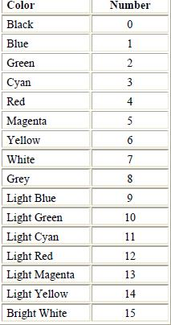

ExampleHW : 6

1. designed window containing the elements of the third command button controls are as follows:

- The first element change the background color model to the color redRED

- The second element change the background color model to the color green GREEN

- The third element change the background color model to the color blue BLUE

Example: 7 designed a window containing the elemental type Command Button controls are as follows:

11. The first element changes the color of the model back to the yellow color by clicking on the left mouse button or use overlay Muftahi) C + Alt (

11. The second element یnھa implementation.
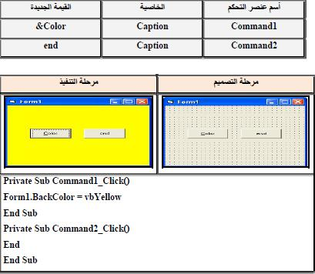

Text Box Tex tBox

Text Box Textbox represents the best way to interact with the user and to obtain input values ​​ment .ھzh tool یbیnھa the following figure:
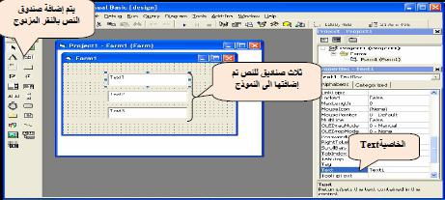

The most important text box events:

- Click and this event is triggered when the pressure is on the text box.

- DblClick and this event is triggered when the double pressure on the text box.

- Change and is triggered when this event is deleted, or add text to the TextBox when any change in the contents of the text box.

- Event GotFocus to get the cursor Curser during the implementation process and this event is triggered when the cursor enters a TextBox in the implementation phase.

- Cursor loss occurred LostFocus and this event is triggered when the cursor loses TextBox Curser in the implementation phase.

The event of the default text box is the event Change which starts as soon as you start changing the contents of the text box.
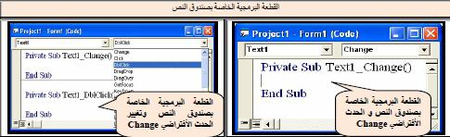

The most important characteristics of the text box:

- Name

This feature is used to change the name your fund text that appears in the code software it has been explained in detail this feature with the control .Command Button

Note:

The text box has a feature Caption and to view Zaھrیh is a text box is possible to use a feature .Text

- TEXT .2

This feature is used to enter values ​​artefact numerical by the user and output the results of the program will be the value of this artisanal default instrument when Achtیarھa are Text followed by the Fund on the form sequence as is evident in the previous form and usually preferred that the text box is empty when implementation to allow the user to enter the values ​​that یrیdھa easily.

- Text mode for text box : Setting the Text Box

TextBoxName.text = "text"

Where representing the Text text you want to enter to the Fund and to you the following example:

Text1.Text = "Hello"

- Get the text from : TextBox

When you want to take the inside We use the following formula TextBox:

VarName = TextBoxName.Text

Accounting for VarName name of the variable that holds the value of the contents of the TextBox, it is possible to change this feature manually or through the code with the following code:
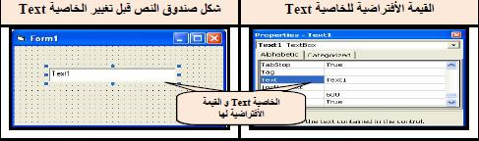

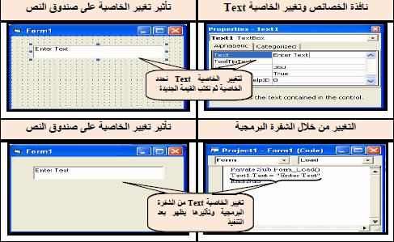

Note

In the picture showing the property change Text of the code through the code was written in the code segment's code event of the Form Load Form that this event is triggered as soon as the program implementation (when pressed) the F5 key or

Pressure on the order of implementation .

Example 8: The window is designed to read a written text in the text box and then First marker shows the same text in the text of the marker, Secodn box by using a command button marker: Display

The solution:

- Open the file type of an Executive . Standard EXE

- addition TextBox and set the following properties) in the window: (Propirtes

Name = Text1

Text = ""

- Changing the name of the Fund to First

- addition TextBox and set the following properties:

Name = Text2

Text = ""

- Changing the name of the Fund to Second

- addition Command Button and set the following properties pric:

Name = CmdDisplay

Caption = Display

7. add a Label element and setting the following properties:

Caption = Working With TextBox

This will be the code example as follows

Source Code:

Private Sub CmdDisplay_Click ()

dis = Text1 .Text

Text2.text = dis

End Sub

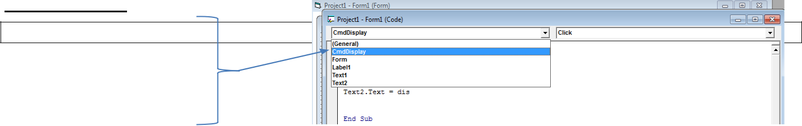

The implementation will be as follows:
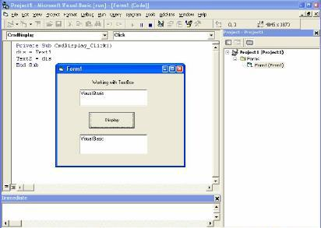

Note that all Code has been Daھa in the command button event under click any event that the implementation of this code is only when you press the command button. For the code of this program was announced to retain variable dis entered into designated at TextBox and then display its contents in the second text box.

  - :How will the code without using any Mngی
- Font

This function determines the settings of writing within the text box has been Hrahھa within the control Command Button

And it is changed as previously passed manually or through the code.

Example : 9Designed window containing the text box and ordered four buttons to control the writing within the text above with box and as follows:

- When implementation is the text box is empty and the designation of the controls reflect the principal Bھa work.

- Command1 makes writing text inside the box dark color when the event .Click

- Command2 makes writing text inside the box tilted at the event .Click

- Command3 makes writing within the text box 16 when the size of the event .Click

- Command4 font name prints the user to write inside the text box.

HW

- Properties ExceptAad:

Determine the characteristics of the text box space dimensions through properties Width, Height and fund site for the upper left corner of the form through the properties Top, Left has been Hrahھa within the Command Button control is changed as an element over the previously manually or through the code.

- Color characteristics:

There are two properties Mtalguetیn special color Ohdھma the background color of the text box feature namely Backcolo and the other is the feature writing color namely feature Forecolor It is possible to change these two properties manually) through the properties window (or through the code code:
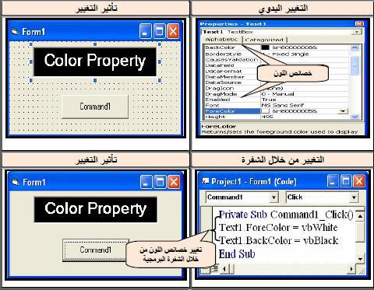

➢ As well as the background color of the text d Back Color
Text1.BackColor = QBColor (Number)
- Also "to put the color of the text inside TextBoxIs the use of the following sentence:

Text1.ForeColor = QBColor (Number)

ASSigment-1

Re-write the example (10) according to the following properties:

Change the text box color bachground.

Change the text insude the text bxo.

Assigment-2:

Designed interface and type the program change the background color for TextBox each time a different color by simply pressing the Command in charge of that color as follows:

Command1 = Red

Command2 = Green

Command3 = Blue

Note:

It must be the names of the Commands function on Dیvtھa.

Example : 11Window is designed to change the color type text within the text box as shown in the following form:
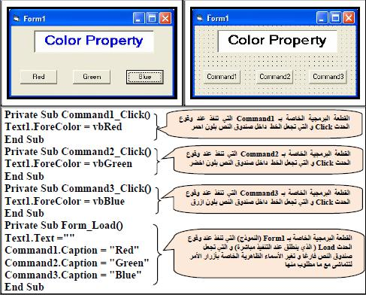

- Alignment feature : Alignment

This feature determines the alignment within the text box and have this feature three options:

- Writing the text to the left of the text box) feature takes value(0

- Writing text to the right of the text box) feature takes value(1

- Writing text central text box) feature takes value ) 2

Private Sub Form_Load ()

Text1.Algiment = 0
Text2.Algiment = 1
Text3.Algiment = 2
End Sub

Assigment3:

Design GUI, and write aprogram in VB according to the following prorestise:

1.Three textbox.

2.The first textbox has right algiment.

3.The second texbox has letf algiment.

4. The third textbox has center algiment.
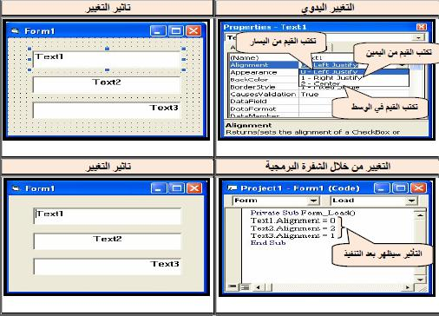

Assigment4:

Write a VB program accoding to the following GUI:
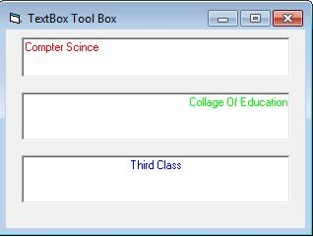

7. feature: Multiline

This function takes the value logic True, False is used to enable the writing of texts on several lines .ngیr this feature manually through the only window properties. Note that the value of logical True to enable this feature) activate the) Multiline The value of False Vھa to write text on one line.
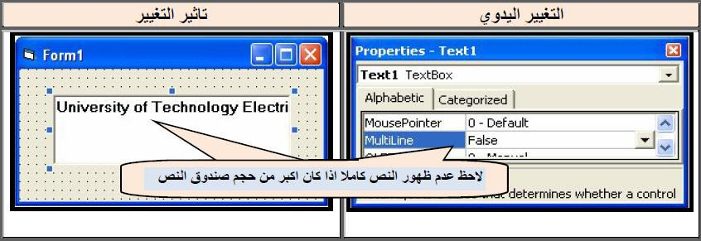

You can change the feature Multiline through programming code as it is possible to read this feature only without Ngیrھa.

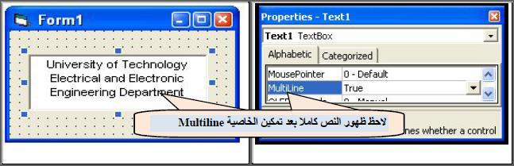

Example: The designed window displays the following text in the text box as soon as the implementation of the program:

An error occurred

Pleas try again

Design steps for this example:

- Open an executable file Standard EXE

- Add Item Label and put him the following feature:

Caption = work with text box

- Add Item Text Box and put him the following feature:

Multiline = True

8. feature: Passwordchar

This feature is usually used in the funds allocated to enter the password text that would prefer to remain confidential and private user only when it is activated this feature to replace each character enters the text box marked with specified by the programmer, which is often . (*)

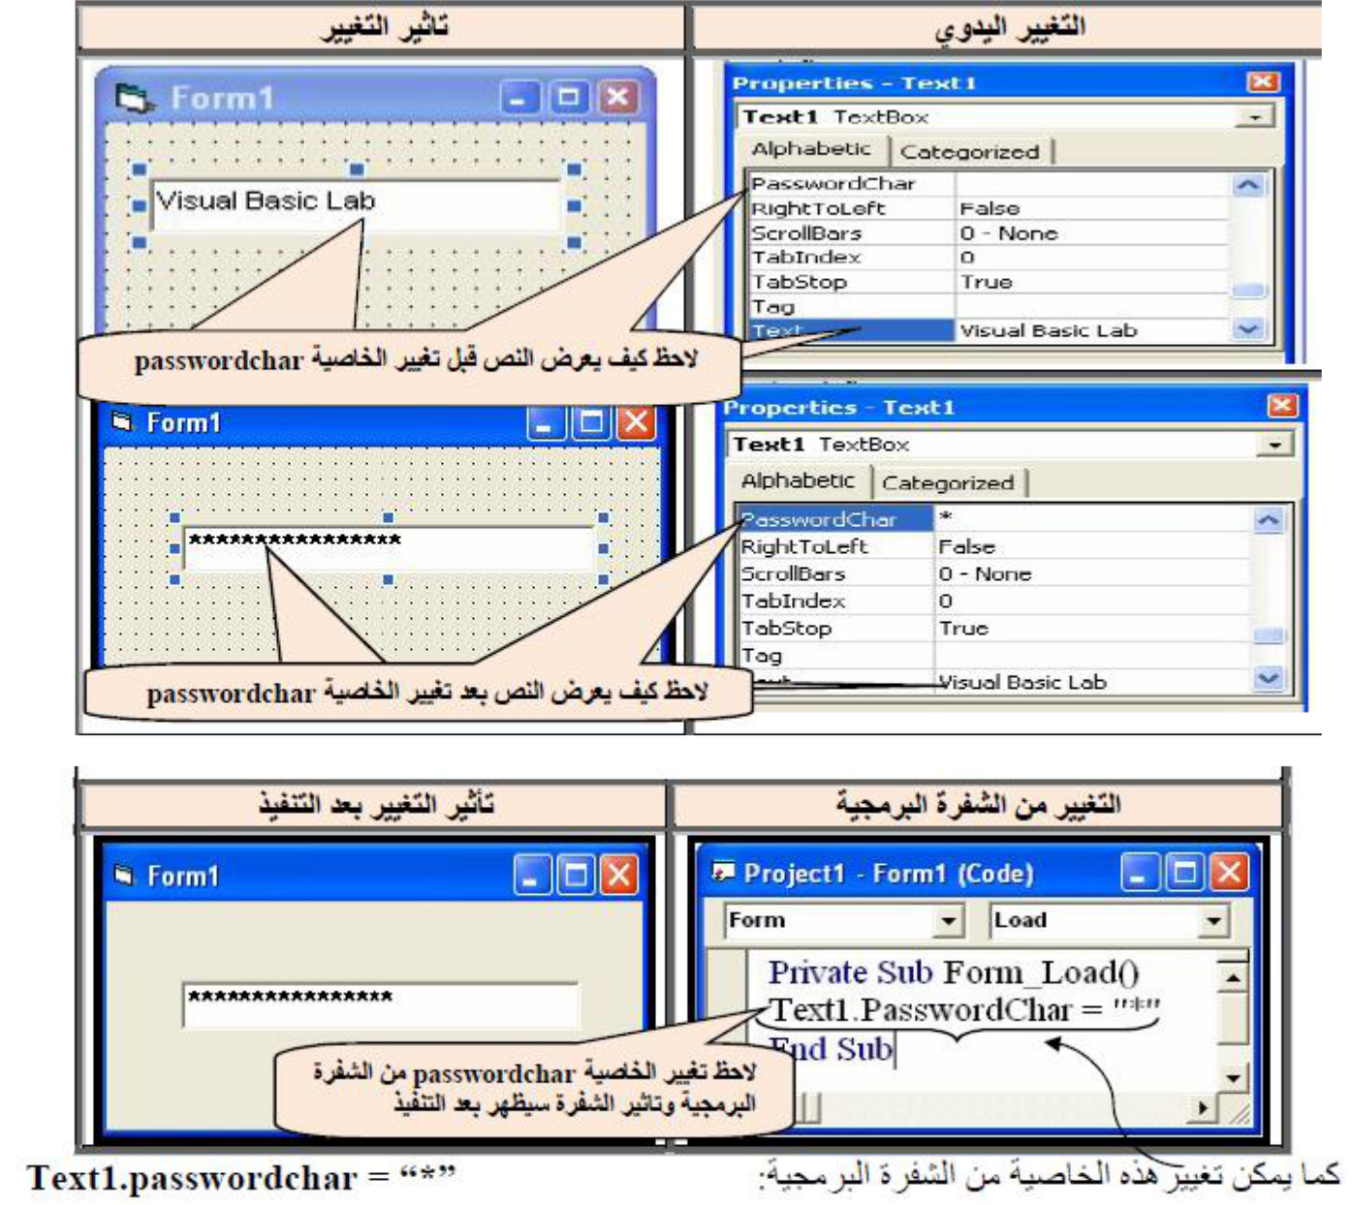

9. feature: Maxlength

This feature specifies the number of text characters that you want to Badkhalھa in the text box and can be changed through the properties window or by the code of the code .alqیmh default this feature 0 namely enables the user to enter any text without specifying its length. In the case of desire determines the length of the text to give this feature a number represents the number of characters allowed Bھa.
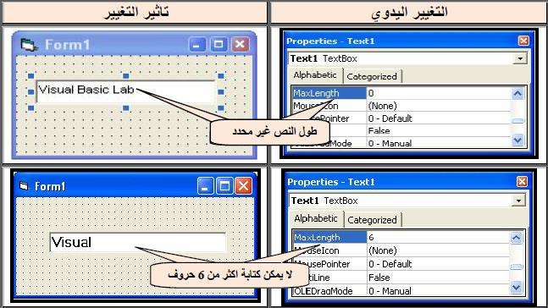

Also you can change this feature through the code and the code as follows:

Text1.MaxLength = 0

number Text1.MaxLength = Value

- Feature : Locked

This feature works on enabling direct or failure enable editing of the contents of the text box to allow or not to allow the user to change the value that was assigned him directly through the text box .tokhz This feature is one of the two values ​​Almntqیtیn True, False and possible property change in two ways:

- Manual change or through the code with the following code:

Text1.Locked = True

Text1 .Locked = False

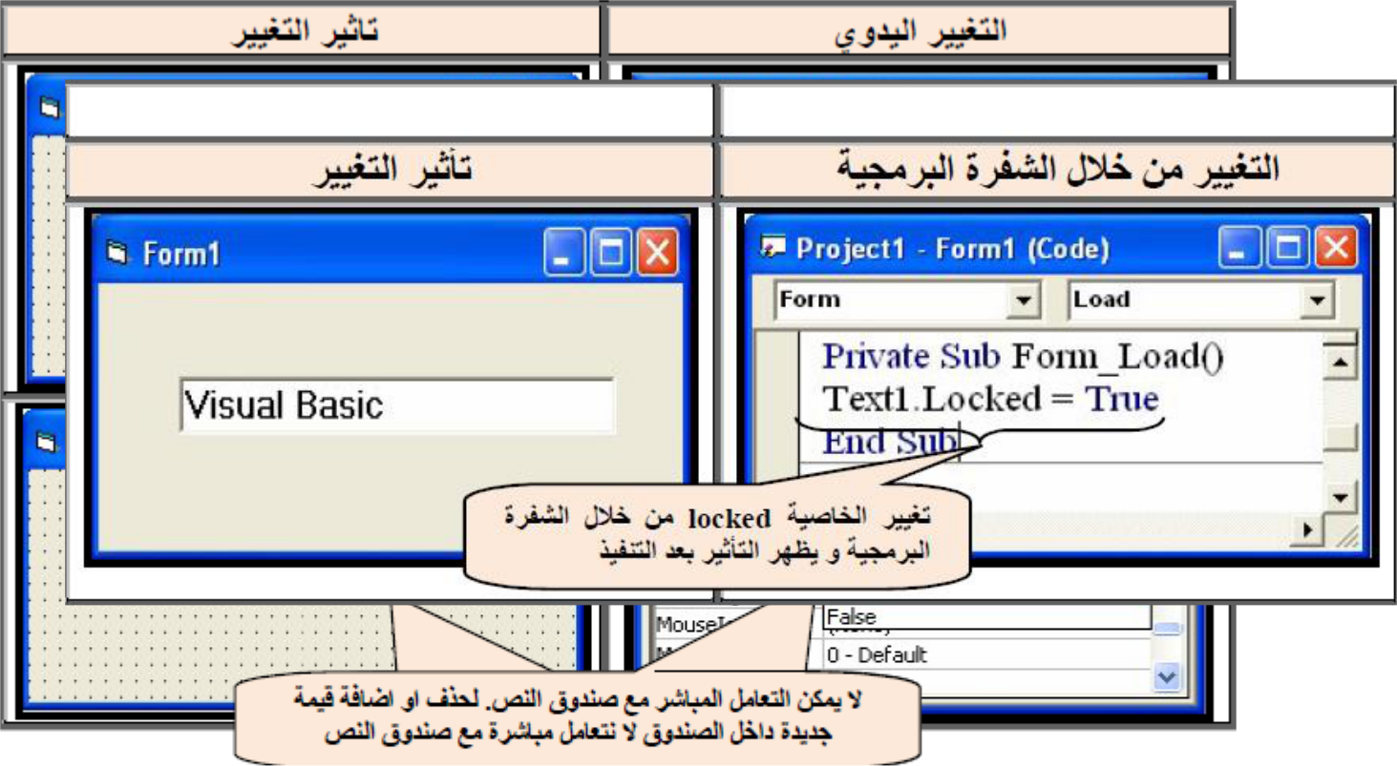

- Feature : Enabled

Over mention this feature in the control Command Button namely lead to the blocking effect of the external event when the implementation of the program code for the item, which has become a feature of his Enabled recognized at logical .False

Illustrations : Designed window containing a single text box is empty when implementation and when you start typing the user name within the text box will be the background color black box and write green color and font sizeDark 16.
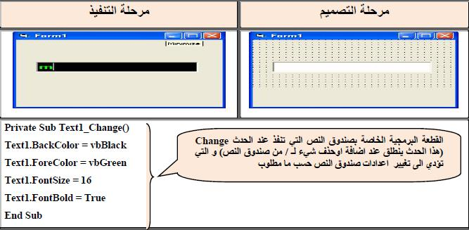

Assigment:

Design a GUI, and write a VB program according to the following propertise:

1.Add Texbox that work as Password that chnge the enterd data to the symble $.

2.Change the textbox color back to green after the first enterd.

3. The max. length for the textbox = 10 characters.

4.Add a label in the center of GUI as: "ENTER YOUR 10 CHARACTERS OR NUMBERS"

5.Make the text alligement paste in the center fo textbox.

Example: Designed window containing the text box and buttons ordered to do the following:

- After implementation directly a user can delete or add something to the contents of the text box with changing the names of each Zaھrیh elements are in line with the work of which Tlob.

- Command1 can text box to write a response to him and alter your color line for the text box to the green and background color to yellow.

- Command2 can not be text box to write a response to it.
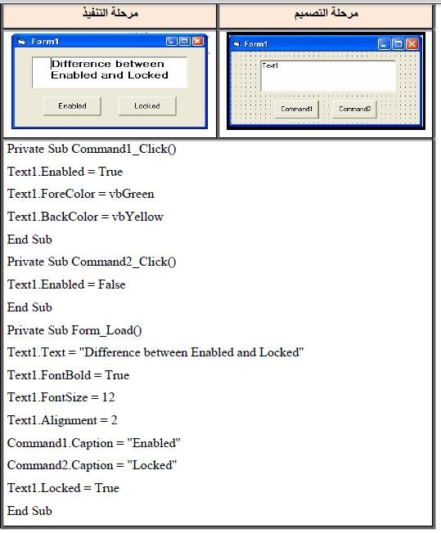

Example :Designed window describes how to perform an operationCut and Paste by using the Text property of the text box.
