Ministry of Higher Education
And Scientific Research
Al Hikma University College
Department of Medical Laboratory Techniques
Lab Management: Lecture 2
Assist.Lec: Lujain A. Ghannawi

The role of Laboratory in the diagnosis and control of infection

What is the Infection?

An infection occurs when a microorganism — such as bacteria, fungi, or a virus — enters a person’s body and causes harm. In many cases, the immune system can stop these pathogens from multiplying in the body. If not, serious damage can result.
The microorganism uses that person’s body to sustain itself, reproduce, and colonize. These infectious microscopic organisms are known as pathogens, and they can multiply quickly.
They can spread in several different ways, including through:
- Skin contact.
- The transfer of body fluids.
- Contact with feces.
- Ingesting contaminated food or water.
- Inhaling airborne particles or droplets.
- Touching an object that a person carrying the pathogen has also touched.
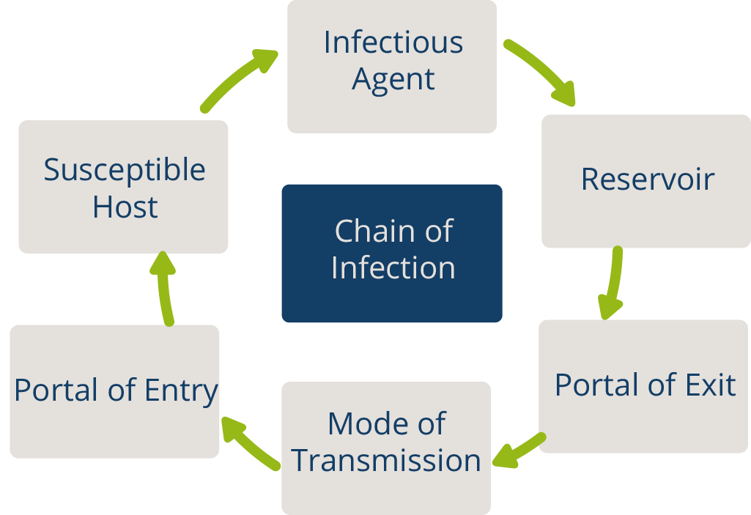

The role of the microbiology laboratory
The isolation and characterization of microorganisms causing infections performed by the microbiology laboratory has two important functions. The first is clinical - everyday management of infections. The second is epidemiological - knowledge of an infective microbe in a patient can lead to finding its source and route of transmission. This allows staff to stop infections from spreading. Furthermore, the microbiology laboratory interprets microbiology data for clinicians and for IPC professionals (Infection Prevention and Control), thus participating in HCW education (Health Care Workers). The microbiology laboratory also participates in the development of an institution’s antibiotic policy.
Some infections must be quickly diagnosed clinically and treated empirically without knowledge of the causative microorganism or determination of antibiotic susceptibility (e.g., acute meningitis, sepsis, or severe pneumonia). However, if there is a clinical suspicion of infection, laboratory tests may confirm the diagnosis. Most HAIs are caused by bacteria and fungi that can be more antibiotic resistant than community-acquired pathogens or their susceptibility to antibiotics is less predictable. Etiological diagnosis of HAIs is therefore exceptionally important for targeted antimicrobial chemotherapy.
The microbiology laboratory is becoming more important in clinical medicine and in the prevention of HAIs (Healthcare-associated infections). (HAIs) are infections people get while they are receiving health care for another condition, especially as new or antibiotic-resistant pathogens emerge and new diagnostic technologies are developed.
The microbiology laboratory should be able to diagnose the most common infectious agents, especially those causing HAIs. The laboratory should also be able to determine susceptibility to antibiotics for bacteria and fungi. Targeted antimicrobial therapy will lead to better patient outcomes, and as eradication of a pathogen is achieved earlier, the danger of transmission to other patients will be decreased.
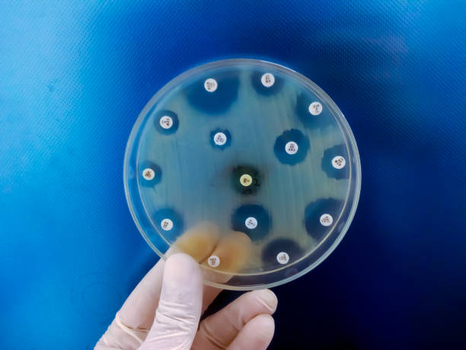
The right specimens from appropriate sites must be taken using proper techniques. The microbiology laboratory staff can assist in ensuring good specimens by educating other staff in proper collection techniques. Identification of the microorganism and its antibiotic susceptibility should be as precise as possible (identification to the species level).
Microbiological diagnostic methods can be divided into two types:
1. Direct methods (smear from specimens, isolation of infectious agents on culture media, or proof of microbial antigens or nucleic acids in the specimen).
2. Indirect methods – proof of immune response to the infectious agents (serology).
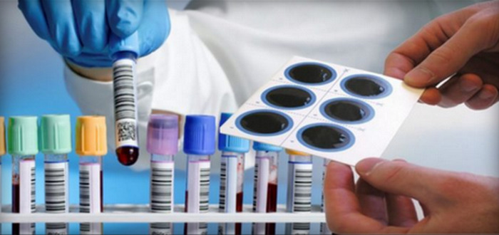

An important new technology in microbiology is molecular diagnostics (Polymerase chain reaction PCR). Diagnosis can be rapid as it is not dependent on waiting for microbial growth in cultures. These tests are sensitive, as they are based on detection of only a few microorganisms; and they are specific, detecting microbe-specific genes.
Alert organism reports
The early isolation of a new or unusual microorganism, without any further typing, enables the ICT to take appropriate measures to stop it from spreading. The ICT should identify, together with laboratory personnel, possible ‘alert’ microorganisms, such as multi-resistant or highly pathogenic microorganisms (e.g., methicillin resistant Staphylococcus aureus (MRSA), vancomycin intermediate Staphylococcus aureus (VISA), vancomycin resistant enterococci (VRE), multidrug resistant (MDR) P.aeruginosa, MDR A.baumannii, MDR M.tuberculosis, C.difficile, extended spectrum beta-lactamase (ESBL) Enterobacteria, carbapenem-resistant Enterobacteria (CRE), E.coli 0127, Legionella spp, penicillin resistant (PR) Streptococcus pneumoniae, etc.). Any new isolates should be reported immediately to the wards and the IPC. Alert organism surveillance may be all that can be performed if the facility is understaffed. In addition, laboratory staff may report clustering of infections (two related isolates in different patients in the same time frame).
The guidelines of IPC instruct providers to take steps to prevent the spread of disease, such as providing training, practicing hygiene, disinfecting spaces, and using personal protective equipment.
In every clinical laboratory in which biological samples are investigated, the first IPC concern is usually exposure to viruses that are spread through blood and bodily fluids (human immunodeficiency virus [HIV] and hepatitis B and C viruses [HBV, HCV]). It is very important that laboratory workers take all necessary preventive measures against those viruses.
Laboratory workers must have specific training to work with microbes and take all standard precautions with all biological specimens and microbial cultures (hand hygiene, disinfection of the environment, specific precautions with sharps, working in biological safety cabinets if aerosols may be created, proper disposal of waste, and sterilization of culture material once testing is complete).
As free education resources are now widely available on the internet, the microbiologist gives training in basic microbiological strategies to deal with each specific infection control situation, evaluation of resources needed.
The laboratory should follow good laboratory practices and guidelines from WHO, the Clinical and Laboratory Standards Institute (CLSI) or the European Committee on Antimicrobial Susceptibility Testing (EUCAST) in Organization, Storage, Analysis and Control.
Storage and analysis of information are usually computerized, and the laboratory information system is usually integrated in the hospital information system. Surveillance data are analyzed and reported promptly on a regular basis.

